EGOOLA.COM
Database Redesign Proposal
From 71 Legacy Tables to a Normalized, Scalable Schema
camelCase Fields, a Universal Audit Trail, Full Field-Level Documentation, and Sample Data for Every Table
Revision 5 — builds on the reviewed Revision 4 proposal and incorporates the stakeholder's own hands-on edits to it. Every field name across the schema is now camelCase; every business table carries the same six-field audit trail (createdBy/creatorType/creatorName, updatedBy/updaterType/updaterName) alongside createdAt/updatedAt, because splitting identity into three separate tables (admins/sellers/users) means a bare numeric id can no longer say by itself who touched a row. Admin, seller and buyer accounts each get their own dedicated media table. Every field is listed one per row with its own description and a realistic example value. Every table now opens with a short, plain-language account of the user action that actually produces a row in it, and closes with two fully worked sample records drawn from one consistent cast of example accounts, listings and orders, so the same seller, buyer and listing recur across sections instead of each table's sample data floating in isolation. The diagram set grows from 11 to 25: every flow diagram is redrawn against the new field names, several new flow diagrams are added for sub-journeys that didn't have their own diagram before, and a new relationship diagram is added for every module, showing at a glance how its tables connect through foreign keys.
Prepared: August 2026
Document type: Technical Design Proposal — for review before migration planning

Contents
This list updates automatically in Microsoft Word. If page numbers show as blank, right-click the list and choose “Update Field.”

1. Redesign Philosophy
The current schema (71 tables) grew feature-by-feature: every new listing format, every new payment path, and every new category level got its own table instead of extending an existing one. That is workable at the start but becomes expensive as the catalog grows — the same bug class (a missing ownership check, an inconsistent status column, a hardcoded commission rate) ends up duplicated across five near-identical tables instead of fixed once. This redesign applies six consistent patterns everywhere they fit, so that once a reader understands one table they already understand the shape of the other thirty-one:
- Collapse parallel, same-shape tables into one table with a type column. The five listing formats (products, used_malls, village_products, retail_shops, wholesales, brand_walls) and the service listings become one listings table; the six category tables become one categories table; the scattered payment/withdrawal tables become one payments ledger. Wherever you see an enum column called catalogType, orderType, purpose, or similar in the tables below, that column is doing the job several legacy tables used to do separately.
- Use self-referencing trees instead of fixed-depth tables. Categories currently stop at three hard-coded levels (grand → parent → child). A parentId column on a single table supports any depth without a schema change — a category can nest five or six levels deep the day a merchandising team asks for it, with no migration required.
- Snapshot money and status at the moment they matter. Commission rate, price, and delivery address are copied onto the order/orderItem at the time of the transaction, so a later rate change or listing edit never silently rewrites historical orders — and so every order carries the numbers needed to audit it without joining back through five tables.
- A dedicated media table per owning entity, not one shared polymorphic table. Every account type — admins, sellers, and buyers — gets its own gallery table (adminMedia, sellerMedia, buyerMedia), and every listing gets its own (listingMedia). Each keeps a normal, typed foreign key back to its single owner — no mediable_type/mediable_id pairing to get wrong, no risk of one gallery query accidentally pulling another entity's files. Every media table, without exception, carries exactly the same three content fields — mediaType, mediaPath, mediaUrl — so a developer who has seen one gallery table has seen them all; the only thing that varies between an admin's, a seller's, and a buyer's gallery is which identity table its foreign key points back to (plus, for the three identity-document galleries, one extra mediaFor classifier that listingMedia doesn't need, since a listing's photos don't need to distinguish an NID from a certificate).
- Name every field in camelCase, consistently. countryId, addressLine, createdAt — never country_id, address_line, created_at. This matches how the field names already look once they cross into JSON in an API response or a JavaScript frontend, so there is no silent renaming step between what the database calls a column and what the application calls the same value.
- Give every business table the same audit trail. createdBy / creatorType / creatorName and updatedBy / updaterType / updaterName ride alongside the usual createdAt / updatedAt on every table below except the handful of framework-owned tables (notifications, jobs, failed_jobs, migrations) that Laravel itself writes and that have no real business "creator" to record. This exists specifically because of the first bullet's identity split: once admins, sellers and users are three separate tables, admin #14, seller #14 and user #14 all exist at the same time, so a bare createdBy = 14 column is genuinely ambiguous without a companion creatorType column saying which of the three tables it points into. creatorName/updaterName are a denormalized convenience on top of that — a snapshot of the actor's display name at the moment they acted, so an audit screen can show "Edited by Rafiq Traders" without joining three separate identity tables just to render one log line.
Where a legacy bug from the platform audit can be closed by the schema itself — not just by an application-code fix — that is called out explicitly in the relevant section below, in a green "Bug fixed at the schema level" box. Where this revision found and closed a gap or an inconsistency in the redesign's own earlier drafts, that is called out the same way, in context, rather than silently changed.

2. Before / After Summary
The table below is a map, not the territory — read it as a quick orientation before Section 3 works through every table in full. A few rows need a short explanatory footnote because one legacy table's data now lands split across two different rows below (seller identity documents used to be one lump under "Seller business profile"; they are now counted under "Auth & user profile" instead, since a dedicated media table is really an identity-account concern, not a business-profile concern).
Area | Legacy tables | New tables | Reduction
Auth & user profile | users, user_infos, verifies, verify_phone, otps, otp_logs, forget_otps, password_resets, contacts, skills, interests, edcations, experiences, company_files, certificats (15) | admins, adminMedia, sellers, sellerMedia, users, buyerMedia (6) | 15 → 6
Seller business profile | companies, documents* (2 of the original 4 — company_files/certificats now counted above, documents now counted below) | sellerInfos (1) | 2 → 1
Categories | grand_categories, parent_categories, child_categories, service_grands, service_parents, service_children (6) | categories (1) | 6 → 1
Listings / catalog | products, product_images, used_malls, village_products, retail_shops, wholesales, brand_walls, services, service_images, measurements (10) | listings, listingPriceTiers, listingMedia, measurements (4) | 10 → 4
Bidding & hiring | bid_for_services, hireds, hire_pays, service_orders, order_pays (5) | bids (folds into orders / orderItems / payments below) (1) | 5 → 1
Orders, cart & payments | carts, sales, orders, billings, shippings, delivery_costs, payments, payment_requests, balances, refund_histories, transactions, commissions, commission_payments, seller_payments (14) | carts, cartItems, orders, orderItems, payments, addresses (6) | 14 → 6
Buyer inquiries | simple_reqs (1) | quoteRequests (1) | 1 → 1 (bug fixed)
Messaging | chats, messages (2) | conversations, messages (2) | 2 → 2 (renamed)
Reviews & favourites | reviews, favourits (2) | reviews, favourites (2) | 2 → 2 (schema tightened)
CMS / settings | banners, sidebar_banners, email_contents, others (4) | banners, emailTemplates, settings (3) | 4 → 3
Geography | countries, states, cities, unions, upazilas (5) | countries, states, cities, thanas (4) | 5 → 4 (dormant table dropped, thana table renamed for clarity)
Notifications & system | notifications, jobs, failed_jobs, migrations, visitors (5, visitors dormant) | notifications, jobs, failed_jobs, migrations (4) | 5 → 4 (dormant visitors table dropped)
Net: 71 legacy tables → 35 new tables (roughly a 51% reduction), while adding capabilities the old schema could not express cleanly: unlimited category depth, unlimited bulk-pricing tiers, a single auditable payment ledger, and — new in this revision — a uniform, queryable record of who created and last touched every row in the system. Media/attachments are not a separate cross-cutting module in this version — each gallery lives in a dedicated table owned by the entity it belongs to (adminMedia, sellerMedia, buyerMedia, listingMedia), counted within that entity's row above rather than as its own line item.

3. New Schema by Module
Every module below follows the same four-part structure for every table it introduces: how you actually reach that table (the real user action that ends up writing a row into it), what the table is for and why it's shaped the way it is, a complete field-by-field specification (one field per row, with a plain-language description and a realistic example value for each), and two fully worked sample records so you can see what an actual row looks like rather than just its abstract shape. Diagrams come in two flavours throughout this section: a flow diagram shows the journey that produces or touches a table, and a relationship diagram shows how a module's tables connect to each other and to tables in other modules through foreign keys.

3.1 Geography Reference Data
Every profile, listing and order in Egoola needs to say where it is — a seller's registered address, a buyer's delivery address, a listing's pickup location. Rather than each of those tables inventing its own free-text location fields, they all point into the same four-level geography reference: country, then state/division, then city/district, then thana/union. These four tables are defined first, ahead of everything else in Section 3, precisely because almost every table that follows leans on them through a countryId / stateId / cityId / thanaId column.
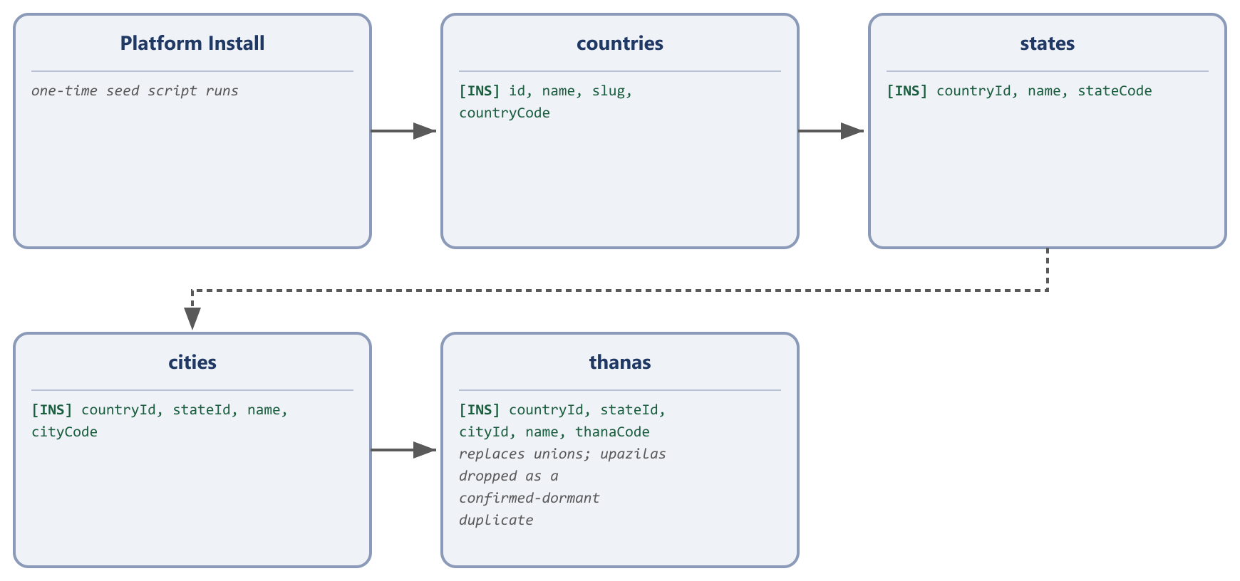
Reference data, seeded once at install time — every address field elsewhere points into this chain.
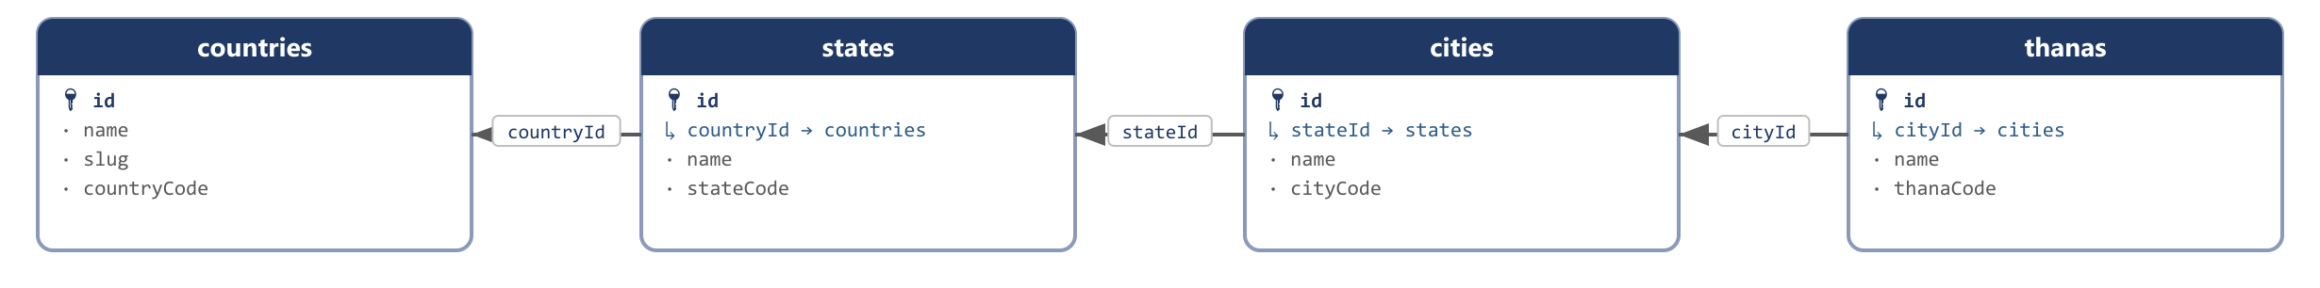
How the four geography levels relate to each other.
Replaces: countries, states/divisions, cities/districts, thanas/unions, upazilas/villages

countries
How you reach this table: Nobody creates a country through the app. This table is seeded once, from a standard countries reference package, when the platform is first installed — the same way a fresh Laravel install seeds its migrations table. Every other geography table, and every address field on admins, sellers, users, listings and orders, ultimately traces back to a row here through a countryId column.
The top level of the location hierarchy. A small, rarely-changing reference table — new rows are only ever added if Egoola expands into a country it doesn't already list.
Field | Type | Description | Example
id | bigint PK | Auto-incrementing primary key. | 1
name | varchar | The country's display name, shown throughout the seller/buyer address pickers. | Bangladesh
slug | varchar, unique | URL-safe identifier derived from name, used in country-scoped storefront links. | bangladesh
countryCode | varchar | The international dialing prefix, used to format and validate phone numbers on signup. | +880
flagPath | varchar, null | Storage path to the country's flag icon file. | flags/bd.png
flagUrl | varchar, null | Public CDN URL for the same flag icon, served directly to the browser. | https://cdn.egoola.com/flags/bd.png
createdBy | bigint, null | ID of the actor who created this row — an admin, seller, or user id depending on creatorType; null when the system created it automatically (e.g. a payment gateway webhook). | 14
creatorType | enum(admin | seller | user | system) | Which actor table createdBy points into. A plain numeric id is ambiguous by itself — admins, sellers and users each have their own id sequence, so id 14 could be any of the three without this column. | seller
creatorName | varchar, null | A denormalized snapshot of the creator's display name at the moment this row was written, so an audit screen can show “Created by Rafiq Traders” without joining three different actor tables. | Rafiq Traders
updatedBy | bigint, null | ID of the actor who last modified this row. Same ambiguity as createdBy, resolved the same way. | 14
updaterType | enum(admin | seller | user | system) | Which actor table updatedBy points into. | seller
updaterName | varchar, null | Denormalized snapshot of the last editor's display name at the time of the edit. | Rafiq Traders
createdAt | timestamp | Row-creation timestamp, maintained automatically by the framework. | 2026-03-14 10:22:00
updatedAt | timestamp | Last-modification timestamp, maintained automatically by the framework. | 2026-03-14 10:22:00
Sample data
Field | Sample Record 1 | Sample Record 2
id | 1 | 2
name | Bangladesh | India
slug | bangladesh | india
countryCode | +880 | +91
flagPath | flags/bd.png | flags/in.png
flagUrl | https://cdn.egoola.com/flags/bd.png | https://cdn.egoola.com/flags/in.png
createdBy | null | null
creatorType | system | system
creatorName | Geo Seed Script | Geo Seed Script
updatedBy | null | null
updaterType | system | system
updaterName | Geo Seed Script | Geo Seed Script
createdAt | 2024-01-01 00:00:00 | 2024-01-01 00:00:00
updatedAt | 2024-01-01 00:00:00 | 2024-01-01 00:00:00

states
How you reach this table: Seeded alongside countries at install time, scoped underneath one. Loaded the moment a seller, buyer, or admin picks a country in an address form — the state dropdown re-populates from this table filtered by countryId.
The second level of the location hierarchy (Bangladesh calls this a Division). Reference data, not normally edited after the initial seed.
Field | Type | Description | Example
id | bigint PK | Auto-incrementing primary key. | 1
countryId | bigint FK → countries | The country this state belongs to. | 1
name | varchar | The state/division's display name. | Dhaka Division
slug | varchar, unique | URL-safe identifier derived from name. | dhaka-division
stateCode | varchar | Short internal code for the state, used in reporting exports. | DHA
flagPath | varchar, null | Storage path to an optional state emblem/icon, if one is configured. | emblems/dhaka.png
flagUrl | varchar, null | Public CDN URL for the same emblem/icon. | https://cdn.egoola.com/emblems/dhaka.png
createdBy | bigint, null | ID of the actor who created this row — an admin, seller, or user id depending on creatorType; null when the system created it automatically (e.g. a payment gateway webhook). | 14
creatorType | enum(admin | seller | user | system) | Which actor table createdBy points into. A plain numeric id is ambiguous by itself — admins, sellers and users each have their own id sequence, so id 14 could be any of the three without this column. | seller
creatorName | varchar, null | A denormalized snapshot of the creator's display name at the moment this row was written, so an audit screen can show “Created by Rafiq Traders” without joining three different actor tables. | Rafiq Traders
updatedBy | bigint, null | ID of the actor who last modified this row. Same ambiguity as createdBy, resolved the same way. | 14
updaterType | enum(admin | seller | user | system) | Which actor table updatedBy points into. | seller
updaterName | varchar, null | Denormalized snapshot of the last editor's display name at the time of the edit. | Rafiq Traders
createdAt | timestamp | Row-creation timestamp, maintained automatically by the framework. | 2026-03-14 10:22:00
updatedAt | timestamp | Last-modification timestamp, maintained automatically by the framework. | 2026-03-14 10:22:00
Sample data
Field | Sample Record 1 | Sample Record 2
id | 1 | 2
countryId | 1 | 1
name | Dhaka Division | Chattogram Division
slug | dhaka-division | chattogram-division
stateCode | DHA | CTG
flagPath | null | null
flagUrl | null | null
createdBy | null | null
creatorType | system | system
creatorName | Geo Seed Script | Geo Seed Script
updatedBy | null | null
updaterType | system | system
updaterName | Geo Seed Script | Geo Seed Script
createdAt | 2024-01-01 00:00:00 | 2024-01-01 00:00:00
updatedAt | 2024-01-01 00:00:00 | 2024-01-01 00:00:00

cities
How you reach this table: Seeded alongside states, scoped underneath one. The city dropdown in any address form re-populates from here, filtered by the stateId the user just picked.
The third level of the location hierarchy (Bangladesh calls this a District). Reference data.
Field | Type | Description | Example
id | bigint PK | Auto-incrementing primary key. | 1
countryId | bigint FK → countries | Denormalized alongside stateId so a city can be filtered by country directly, without joining through states. | 1
stateId | bigint FK → states | The state/division this city belongs to. | 1
name | varchar | The city/district's display name. | Dhaka
slug | varchar, unique | URL-safe identifier derived from name. | dhaka
cityCode | varchar | Short internal code for the city, used in reporting exports. | DHK
flagPath | varchar, null | Storage path to an optional city emblem/icon. | null
flagUrl | varchar, null | Public CDN URL for the same emblem/icon. | null
createdBy | bigint, null | ID of the actor who created this row — an admin, seller, or user id depending on creatorType; null when the system created it automatically (e.g. a payment gateway webhook). | 14
creatorType | enum(admin | seller | user | system) | Which actor table createdBy points into. A plain numeric id is ambiguous by itself — admins, sellers and users each have their own id sequence, so id 14 could be any of the three without this column. | seller
creatorName | varchar, null | A denormalized snapshot of the creator's display name at the moment this row was written, so an audit screen can show “Created by Rafiq Traders” without joining three different actor tables. | Rafiq Traders
updatedBy | bigint, null | ID of the actor who last modified this row. Same ambiguity as createdBy, resolved the same way. | 14
updaterType | enum(admin | seller | user | system) | Which actor table updatedBy points into. | seller
updaterName | varchar, null | Denormalized snapshot of the last editor's display name at the time of the edit. | Rafiq Traders
createdAt | timestamp | Row-creation timestamp, maintained automatically by the framework. | 2026-03-14 10:22:00
updatedAt | timestamp | Last-modification timestamp, maintained automatically by the framework. | 2026-03-14 10:22:00
Sample data
Field | Sample Record 1 | Sample Record 2
id | 1 | 2
countryId | 1 | 1
stateId | 1 | 2
name | Dhaka | Chattogram
slug | dhaka | chattogram
cityCode | DHK | CTG
flagPath | null | null
flagUrl | null | null
createdBy | null | null
creatorType | system | system
creatorName | Geo Seed Script | Geo Seed Script
updatedBy | null | null
updaterType | system | system
updaterName | Geo Seed Script | Geo Seed Script
createdAt | 2024-01-01 00:00:00 | 2024-01-01 00:00:00
updatedAt | 2024-01-01 00:00:00 | 2024-01-01 00:00:00

thanas
How you reach this table: Seeded alongside cities, scoped underneath one. This is the finest-grained level offered in any address form — once a buyer or seller picks a thana, the address is considered complete down to neighbourhood level.
The fourth and finest level of the location hierarchy. The legacy schema actually carried two tables at this level: unions (~5,246 rows, the one every thana_id column in the live application really points to) and upazilas (~560 rows, confirmed by grepping the entire codebase for any write — zero matches, a dormant duplicate). This redesign keeps one real table, named thanas here for clarity, and drops the dormant duplicate outright; every existing thana_id column gets an explicit, enforced foreign key into it instead of an untyped, unconstrained bigint that only worked by convention.
Field | Type | Description | Example
id | bigint PK | Auto-incrementing primary key. | 1
countryId | bigint FK → countries | Denormalized for direct country-level filtering. | 1
stateId | bigint FK → states | Denormalized for direct state-level filtering. | 1
cityId | bigint FK → cities | The city/district this thana belongs to. | 1
name | varchar | The thana/union's display name. | Gulshan
slug | varchar, unique | URL-safe identifier derived from name. | gulshan
thanaCode | varchar | Short internal code for the thana, used in reporting exports. | GUL
flagPath | varchar, null | Storage path to an optional local emblem/icon. | null
flagUrl | varchar, null | Public CDN URL for the same emblem/icon. | null
createdBy | bigint, null | ID of the actor who created this row — an admin, seller, or user id depending on creatorType; null when the system created it automatically (e.g. a payment gateway webhook). | 14
creatorType | enum(admin | seller | user | system) | Which actor table createdBy points into. A plain numeric id is ambiguous by itself — admins, sellers and users each have their own id sequence, so id 14 could be any of the three without this column. | seller
creatorName | varchar, null | A denormalized snapshot of the creator's display name at the moment this row was written, so an audit screen can show “Created by Rafiq Traders” without joining three different actor tables. | Rafiq Traders
updatedBy | bigint, null | ID of the actor who last modified this row. Same ambiguity as createdBy, resolved the same way. | 14
updaterType | enum(admin | seller | user | system) | Which actor table updatedBy points into. | seller
updaterName | varchar, null | Denormalized snapshot of the last editor's display name at the time of the edit. | Rafiq Traders
createdAt | timestamp | Row-creation timestamp, maintained automatically by the framework. | 2026-03-14 10:22:00
updatedAt | timestamp | Last-modification timestamp, maintained automatically by the framework. | 2026-03-14 10:22:00
Sample data
Field | Sample Record 1 | Sample Record 2
id | 1 | 2
countryId | 1 | 1
stateId | 1 | 2
cityId | 1 | 2
name | Gulshan | Pahartali
slug | gulshan | pahartali
thanaCode | GUL | PAH
flagPath | null | null
flagUrl | null | null
createdBy | null | null
creatorType | system | system
creatorName | Geo Seed Script | Geo Seed Script
updatedBy | null | null
updaterType | system | system
updaterName | Geo Seed Script | Geo Seed Script
createdAt | 2024-01-01 00:00:00 | 2024-01-01 00:00:00
updatedAt | 2024-01-01 00:00:00 | 2024-01-01 00:00:00

3.2 Identity & Authentication
The legacy schema ran every account type — internal staff, business sellers, and ordinary buyers — through one users table with a role column, then bolted on twelve more tables (user_infos, verifies, verify_phone, otps, otp_logs, forget_otps, password_resets, contacts, skills, interests, edcations, experiences) to hold everything that role-based table couldn't. This redesign gives each account type its own table instead: admins, sellers, and users (buyers) are three independent registration roots with no shared identity table and no overloaded role column. Each carries its own verification/OTP fields directly, and each gets its own dedicated media table for profile photos and identity documents — no shared, polymorphic gallery to get wrong.
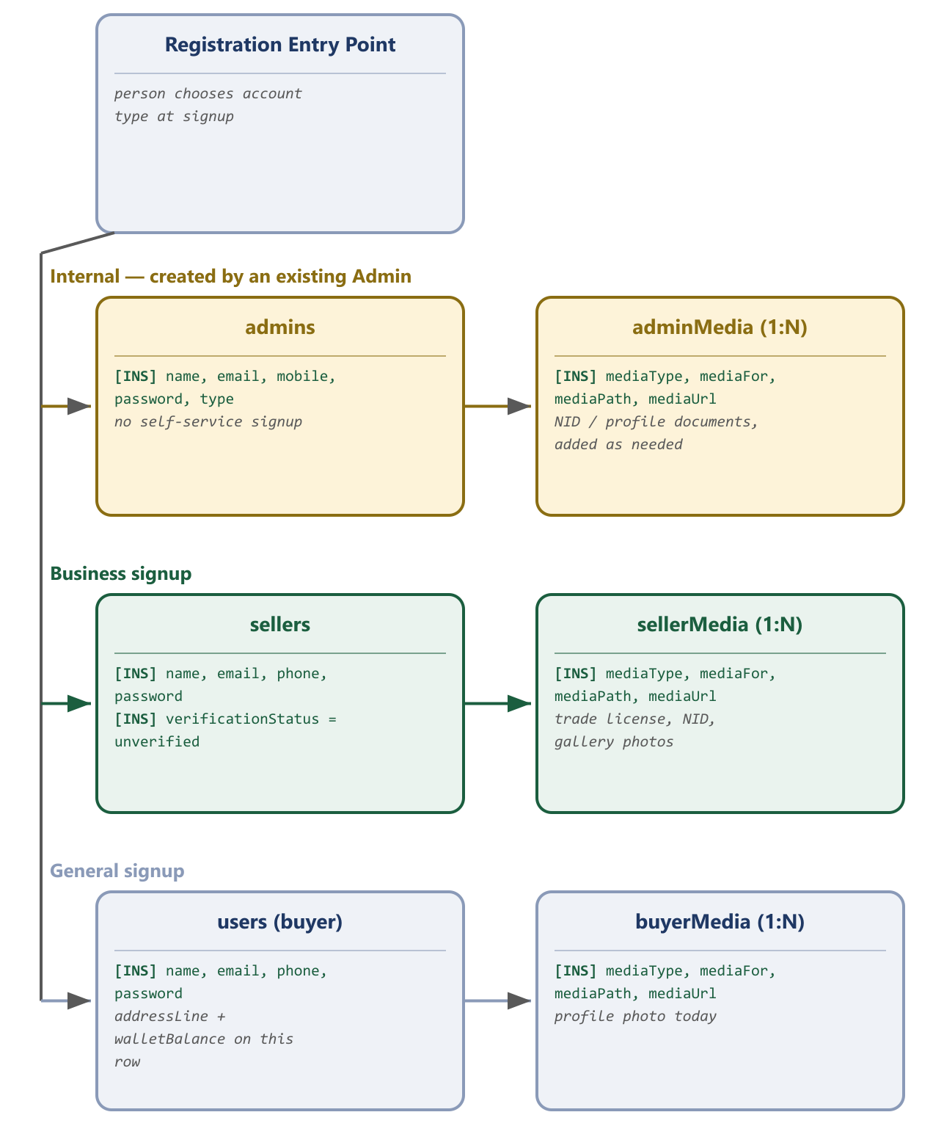
Three independent registration roots — no shared identity table, no overloaded role column.
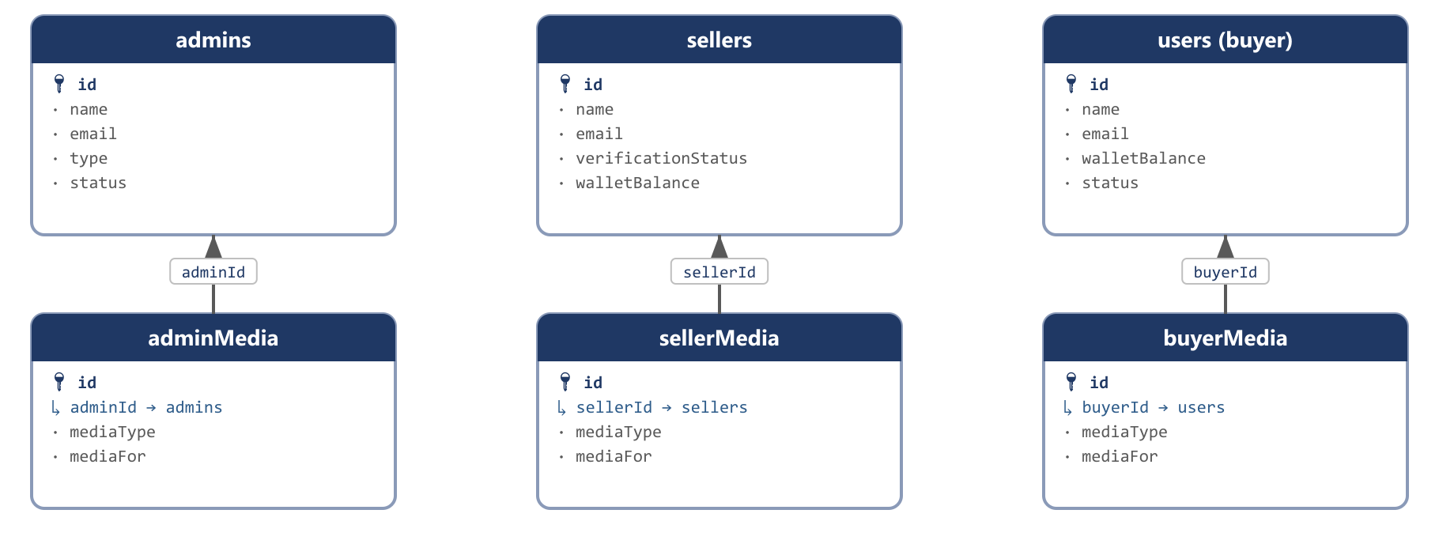
Each identity table owns its own dedicated media table — no shared, polymorphic gallery.
Replaces: users (role column), user_infos, verifies, verify_phone, otps, otp_logs, forget_otps, password_resets, contacts, skills, interests, edcations, experiences

admins
How you reach this table: Reached only from inside the admin panel itself: an existing admin with sufficient permission opens Admin Management → Add Admin and fills in the new teammate's details. There is no public signup form for this table — it is the one identity table in Egoola that can never be self-registered into.
Internal staff accounts — the people who moderate listings, resolve disputes, and manage site content. Distinct from sellers and users because an admin's permissions, verification rules, and profile fields are simply a different shape.
Field | Type | Description | Example
id | bigint PK | Auto-incrementing primary key. | 1
name | varchar | The admin's full name. | Super Admin
email | varchar, unique | Login email address. | admin@egoola.com
mobile | varchar, unique | Login-recovery mobile number. | +8801711000000
password | varchar | Bcrypt-hashed password. Never returned by any API response. | $2y$10$abcdefghijklmnopqrstuv
profilePicPath | varchar, null | Storage path to the admin's profile photo. | admins/1/profile.jpg
profilePicUrl | varchar, null | Public CDN URL for the same photo. | https://cdn.egoola.com/admins/1/profile.jpg
type | enum(super_admin | admin | moderator | support) | The admin's permission tier, checked by route middleware before sensitive actions. | super_admin
status | enum(active | inactive) | Whether this admin can currently log in. | active
skills | json, null | Freeform structured notes on the admin's specialisation — internal reference, not customer-facing. | ["catalog moderation","payments"]
experiences | json, null | Freeform structured work-history notes, kept for internal HR-style reference. | ["3 yrs marketplace ops"]
interests | json, null | Freeform structured notes on areas of interest. | ["fraud detection"]
educations | json, null | Freeform structured education notes. | ["BSc CSE, BUET"]
presentAddress | text, null | Current address, free text. | House 12, Road 5, Gulshan-1, Dhaka
permanentAddress | text, null | Permanent/home address, free text. | Village Rampur, Comilla
countryId | bigint FK → countries, null | Country of the present address. | 1
stateId | bigint FK → states, null | State/division of the present address. | 1
cityId | bigint FK → cities, null | City/district of the present address. | 1
thanaId | bigint FK → thanas, null | Thana/union of the present address. | 1
lastLoggedAt | timestamp, null | Timestamp of the admin's most recent login, shown on the admin-management screen. | 2026-08-30 09:14:02
createdBy | bigint, null | ID of the actor who created this row — an admin, seller, or user id depending on creatorType; null when the system created it automatically (e.g. a payment gateway webhook). | 14
creatorType | enum(admin | seller | user | system) | Which actor table createdBy points into. A plain numeric id is ambiguous by itself — admins, sellers and users each have their own id sequence, so id 14 could be any of the three without this column. | seller
creatorName | varchar, null | A denormalized snapshot of the creator's display name at the moment this row was written, so an audit screen can show “Created by Rafiq Traders” without joining three different actor tables. | Rafiq Traders
updatedBy | bigint, null | ID of the actor who last modified this row. Same ambiguity as createdBy, resolved the same way. | 14
updaterType | enum(admin | seller | user | system) | Which actor table updatedBy points into. | seller
updaterName | varchar, null | Denormalized snapshot of the last editor's display name at the time of the edit. | Rafiq Traders
createdAt | timestamp | Row-creation timestamp, maintained automatically by the framework. | 2026-03-14 10:22:00
updatedAt | timestamp | Last-modification timestamp, maintained automatically by the framework. | 2026-03-14 10:22:00
Sample data
Field | Sample Record 1 | Sample Record 2
id | 1 | 2
name | Super Admin | Farhana Moderator
email | admin@egoola.com | farhana@egoola.com
mobile | +8801711000000 | +8801711000009
password | $2y$10$abcdefghijklmnopqrstuv | $2y$10$zzxxccvvbbnnmmasdfghjk
profilePicPath | null | null
profilePicUrl | null | null
type | super_admin | moderator
status | active | active
skills | null | ["catalog moderation"]
experiences | null | null
interests | null | null
educations | null | null
presentAddress | null | House 3, Road 9, Banani, Dhaka
permanentAddress | null | null
countryId | null | 1
stateId | null | 1
cityId | null | 1
thanaId | null | 1
lastLoggedAt | 2026-08-30 09:14:02 | 2026-08-29 17:40:11
createdBy | null | 1
creatorType | system | admin
creatorName | Initial Seed | Super Admin
updatedBy | null | 1
updaterType | system | admin
updaterName | Initial Seed | Super Admin
createdAt | 2024-01-01 00:00:00 | 2025-02-10 11:00:00
updatedAt | 2024-01-01 00:00:00 | 2025-02-10 11:00:00

adminMedia
How you reach this table: Reached from the admin's own profile-edit screen, or from the admin-management screen when a second admin uploads an identity document for the record (e.g. a scanned NID during onboarding). Every row is a single uploaded file belonging to exactly one admin.
A dedicated gallery table for admin accounts. Today only a profile photo is actually stored directly on admins.profilePicPath, but if the platform later needs to keep an admin's NID or other verification documents on file, this table is where each of those files becomes its own row — no schema change needed later.
Field | Type | Description | Example
id | bigint PK | Auto-incrementing primary key. | 1
adminId | bigint FK → admins | The admin this file belongs to. | 1
mediaType | enum(image | video | document) | The general kind of file stored. | image
mediaFor | enum(nid | birth_certificate | profile_document | other) | What the file actually represents, since an admin can have more than one document on file. | nid
mediaPath | varchar | Storage path/disk key the app writes to and reads from. | admins/1/nid-front.jpg
mediaUrl | varchar | Public/CDN URL served to the browser. | https://cdn.egoola.com/admins/1/nid-front.jpg
createdBy | bigint, null | ID of the actor who created this row — an admin, seller, or user id depending on creatorType; null when the system created it automatically (e.g. a payment gateway webhook). | 14
creatorType | enum(admin | seller | user | system) | Which actor table createdBy points into. A plain numeric id is ambiguous by itself — admins, sellers and users each have their own id sequence, so id 14 could be any of the three without this column. | seller
creatorName | varchar, null | A denormalized snapshot of the creator's display name at the moment this row was written, so an audit screen can show “Created by Rafiq Traders” without joining three different actor tables. | Rafiq Traders
updatedBy | bigint, null | ID of the actor who last modified this row. Same ambiguity as createdBy, resolved the same way. | 14
updaterType | enum(admin | seller | user | system) | Which actor table updatedBy points into. | seller
updaterName | varchar, null | Denormalized snapshot of the last editor's display name at the time of the edit. | Rafiq Traders
createdAt | timestamp | Row-creation timestamp, maintained automatically by the framework. | 2026-03-14 10:22:00
updatedAt | timestamp | Last-modification timestamp, maintained automatically by the framework. | 2026-03-14 10:22:00
Sample data
Field | Sample Record 1 | Sample Record 2
id | 1 | 2
adminId | 1 | 2
mediaType | image | document
mediaFor | nid | profile_document
mediaPath | admins/1/nid-front.jpg | admins/2/employment-letter.pdf
mediaUrl | https://cdn.egoola.com/admins/1/nid-front.jpg | https://cdn.egoola.com/admins/2/employment-letter.pdf
createdBy | 1 | 1
creatorType | admin | admin
creatorName | Super Admin | Super Admin
updatedBy | 1 | 1
updaterType | admin | admin
updaterName | Super Admin | Super Admin
createdAt | 2024-01-02 09:00:00 | 2025-02-10 11:05:00
updatedAt | 2024-01-02 09:00:00 | 2025-02-10 11:05:00

sellers
How you reach this table: A visitor clicks “Sell on Egoola” and fills in the business-signup form (name, email, phone, password). That single submission inserts one row here with verificationStatus = unverified — nothing else needs to exist yet. The seller then verifies email/phone (the OTP columns on this same row get checked and cleared), and separately submits business documents through sellerMedia and sellerInfos before an admin can move verificationStatus to verified.
A seller's own login and account-state row. This single table absorbs what the legacy schema spread across a shared users table plus verifies, verify_phone, otps, otp_logs, forget_otps and password_resets — every OTP/verification/reset field a seller needs lives directly on their own row, with no join required to check login state.
Field | Type | Description | Example
id | bigint PK | Auto-incrementing primary key. | 201
name | varchar | The seller's business or personal display name. | Rafiq Traders
email | varchar, unique | Login email address. | info@rafiqtraders.com
phone | varchar, unique | Login phone number. | +8801711000111
password | varchar | Bcrypt-hashed password. | $2y$10$sellerhashexample0000001
profilePicPath | varchar, null | Storage path to the seller's profile/logo photo. | sellers/201/logo.jpg
profilePicUrl | varchar, null | Public CDN URL for the same photo. | https://cdn.egoola.com/sellers/201/logo.jpg
emailVerifiedAt | timestamp, null | When the email OTP was confirmed; null until then. | 2025-01-05 08:12:00
phoneVerifiedAt | timestamp, null | When the phone OTP was confirmed; null until then. | 2025-01-05 08:20:00
emailOtpCode | varchar, null | The current one-time code sent to email; cleared once verified. | null
emailOtpExpiresAt | timestamp, null | When the current email OTP stops being valid. | null
phoneOtpCode | varchar, null | The current one-time code sent by SMS; cleared once verified. | null
phoneOtpExpiresAt | timestamp, null | When the current phone OTP stops being valid. | null
phoneOtpAttempts | int | Failed-attempt counter for the current phone OTP, resets to 0 on a fresh code — replaces the legacy otp_logs table. | 0
passwordResetToken | varchar, null | One-time token emailed/texted for a forgot-password flow. | null
passwordResetExpiresAt | timestamp, null | When the current reset token stops being valid. | null
rememberToken | varchar, null | Persistent “remember me” login token. | null
verificationStatus | enum(unverified | pending | verified | rejected) | The seller's business-verification state, checked before a listing can be published. | verified
verificationNote | text, null | Admin's reason, if verification was rejected. | null
skills | json, null | Freeform structured skill tags, mainly used on the service side of the catalog. | ["wholesale electronics","import"]
education | json, null | Freeform structured education notes. | null
experience | json, null | Freeform structured business-experience notes. | ["8 years in Dhaka wholesale market"]
interest | json, null | Freeform structured interest tags. | null
presentAddress | text, null | Current business/contact address, free text. | Shop 14, Dhaka New Market, Dhaka
permanentAddress | text, null | Permanent address, free text. | Village Sonargaon, Narayanganj
countryId | bigint FK → countries, null | Country of the present address. | 1
stateId | bigint FK → states, null | State/division of the present address. | 1
cityId | bigint FK → cities, null | City/district of the present address. | 1
thanaId | bigint FK → thanas, null | Thana/union of the present address. | 1
walletBalance | decimal(12,2) | Available balance the seller can request as a payout. | 4520.00
bonusBalance | decimal(12,2) | Promotional/bonus credit, kept separate from real earnings. | 0.00
status | enum(active | suspended) | Whether this seller account can currently trade. | active
lastLoggedAt | timestamp, null | Timestamp of the seller's most recent login. | 2026-08-30 07:40:00
createdBy | bigint, null | ID of the actor who created this row — an admin, seller, or user id depending on creatorType; null when the system created it automatically (e.g. a payment gateway webhook). | 14
creatorType | enum(admin | seller | user | system) | Which actor table createdBy points into. A plain numeric id is ambiguous by itself — admins, sellers and users each have their own id sequence, so id 14 could be any of the three without this column. | seller
creatorName | varchar, null | A denormalized snapshot of the creator's display name at the moment this row was written, so an audit screen can show “Created by Rafiq Traders” without joining three different actor tables. | Rafiq Traders
updatedBy | bigint, null | ID of the actor who last modified this row. Same ambiguity as createdBy, resolved the same way. | 14
updaterType | enum(admin | seller | user | system) | Which actor table updatedBy points into. | seller
updaterName | varchar, null | Denormalized snapshot of the last editor's display name at the time of the edit. | Rafiq Traders
createdAt | timestamp | Row-creation timestamp, maintained automatically by the framework. | 2026-03-14 10:22:00
updatedAt | timestamp | Last-modification timestamp, maintained automatically by the framework. | 2026-03-14 10:22:00
Sample data
Field | Sample Record 1 | Sample Record 2
id | 201 | 202
name | Rafiq Traders | Dhaka Gadget House
email | info@rafiqtraders.com | sales@dhakagadget.com
phone | +8801711000111 | +8801711000222
password | $2y$10$sellerhashexample0000001 | $2y$10$sellerhashexample0000002
profilePicPath | sellers/201/logo.jpg | null
profilePicUrl | https://cdn.egoola.com/sellers/201/logo.jpg | null
emailVerifiedAt | 2025-01-05 08:12:00 | 2025-03-11 10:00:00
phoneVerifiedAt | 2025-01-05 08:20:00 | 2025-03-11 10:05:00
emailOtpCode | null | null
emailOtpExpiresAt | null | null
phoneOtpCode | null | null
phoneOtpExpiresAt | null | null
phoneOtpAttempts | 0 | 0
passwordResetToken | null | null
passwordResetExpiresAt | null | null
rememberToken | null | null
verificationStatus | verified | pending
verificationNote | null | null
skills | ["wholesale electronics","import"] | ["mobile phones","accessories"]
education | null | null
experience | ["8 years in Dhaka wholesale market"] | null
interest | null | null
presentAddress | Shop 14, Dhaka New Market, Dhaka | Shop 22, Elephant Road, Dhaka
permanentAddress | Village Sonargaon, Narayanganj | null
countryId | 1 | 1
stateId | 1 | 1
cityId | 1 | 1
thanaId | 1 | 1
walletBalance | 4520.00 | 0.00
bonusBalance | 0.00 | 0.00
status | active | active
lastLoggedAt | 2026-08-30 07:40:00 | 2026-08-29 21:12:00
createdBy | 201 | 202
creatorType | seller | seller
creatorName | Rafiq Traders | Dhaka Gadget House
updatedBy | 201 | 202
updaterType | seller | seller
updaterName | Rafiq Traders | Dhaka Gadget House
createdAt | 2025-01-05 08:00:00 | 2025-03-11 09:55:00
updatedAt | 2025-01-05 08:00:00 | 2025-03-11 09:55:00

sellerMedia
How you reach this table: Reached during business verification: a seller opens Seller Dashboard → Verification and uploads their trade license, NID and product-gallery images, or later opens Dashboard → Gallery to add more shop photos at any time. Each upload is its own row here, owned by exactly one seller.
A seller's identity-and-business document gallery, plus general shop photos/videos. This one table replaces four legacy tables at once: companies' file columns, company_files, certificats, and the seller-level portion of documents.
Field | Type | Description | Example
id | bigint PK | Auto-incrementing primary key. | 1
sellerId | bigint FK → sellers | The seller this file belongs to. | 201
mediaType | enum(image | video | document) | The general kind of file stored. | document
mediaFor | enum(nid | birth_certificate | certificate | gallery_image | gallery_video | other) | What the file represents — certificate replaces the legacy certificats table; gallery_image/gallery_video replace company_files.what. | certificate
mediaPath | varchar | Storage path/disk key the app writes to and reads from. | sellers/201/trade-license.pdf
mediaUrl | varchar | Public/CDN URL served to the browser. | https://cdn.egoola.com/sellers/201/trade-license.pdf
createdBy | bigint, null | ID of the actor who created this row — an admin, seller, or user id depending on creatorType; null when the system created it automatically (e.g. a payment gateway webhook). | 14
creatorType | enum(admin | seller | user | system) | Which actor table createdBy points into. A plain numeric id is ambiguous by itself — admins, sellers and users each have their own id sequence, so id 14 could be any of the three without this column. | seller
creatorName | varchar, null | A denormalized snapshot of the creator's display name at the moment this row was written, so an audit screen can show “Created by Rafiq Traders” without joining three different actor tables. | Rafiq Traders
updatedBy | bigint, null | ID of the actor who last modified this row. Same ambiguity as createdBy, resolved the same way. | 14
updaterType | enum(admin | seller | user | system) | Which actor table updatedBy points into. | seller
updaterName | varchar, null | Denormalized snapshot of the last editor's display name at the time of the edit. | Rafiq Traders
createdAt | timestamp | Row-creation timestamp, maintained automatically by the framework. | 2026-03-14 10:22:00
updatedAt | timestamp | Last-modification timestamp, maintained automatically by the framework. | 2026-03-14 10:22:00
Sample data
Field | Sample Record 1 | Sample Record 2
id | 1 | 2
sellerId | 201 | 201
mediaType | document | image
mediaFor | certificate | gallery_image
mediaPath | sellers/201/trade-license.pdf | sellers/201/shopfront.jpg
mediaUrl | https://cdn.egoola.com/sellers/201/trade-license.pdf | https://cdn.egoola.com/sellers/201/shopfront.jpg
createdBy | 201 | 201
creatorType | seller | seller
creatorName | Rafiq Traders | Rafiq Traders
updatedBy | 201 | 201
updaterType | seller | seller
updaterName | Rafiq Traders | Rafiq Traders
createdAt | 2025-01-06 09:00:00 | 2025-01-06 09:05:00
updatedAt | 2025-01-06 09:00:00 | 2025-01-06 09:05:00

users (buyer)
How you reach this table: A visitor clicks “Sign Up” on the general (non-seller) registration form and submits name, email, phone and password. One row is created here immediately with the OTP fields empty; the buyer then verifies email/phone the same way a seller does, entirely on their own row.
An ordinary buyer's login and account row — anyone browsing the marketplace to purchase products, hire a service, or post a job request. Structurally a lighter version of sellers: no business-verification workflow, but the same self-contained OTP/reset fields.
Field | Type | Description | Example
id | bigint PK | Auto-incrementing primary key. | 501
name | varchar | The buyer's display name. | Mahin Rahman
email | varchar, unique | Login email address. | mahin.rahman@gmail.com
phone | varchar, unique | Login phone number. | +8801911222333
password | varchar | Bcrypt-hashed password. | $2y$10$buyerhashexample00000001
profilePicPath | varchar, null | Storage path to the buyer's profile photo. | null
profilePicUrl | varchar, null | Public CDN URL for the same photo. | null
description | text, null | Freeform “about me” text shown on the buyer's public profile, if enabled. | null
skills | json, null | Freeform structured skill tags — relevant if this buyer also submits bids/portfolios in the future. | null
experiences | json, null | Freeform structured experience notes. | null
interests | json, null | Freeform structured interest tags, used for listing recommendations. | ["mobile phones","home decor"]
educations | json, null | Freeform structured education notes. | null
emailVerifiedAt | timestamp, null | When the email OTP was confirmed; null until then. | 2025-04-02 12:00:00
phoneVerifiedAt | timestamp, null | When the phone OTP was confirmed; null until then. | 2025-04-02 12:04:00
emailOtpCode | varchar, null | The current one-time code sent to email; cleared once verified. | null
emailOtpExpiresAt | timestamp, null | When the current email OTP stops being valid. | null
phoneOtpCode | varchar, null | The current one-time code sent by SMS; cleared once verified. | null
phoneOtpExpiresAt | timestamp, null | When the current phone OTP stops being valid. | null
phoneOtpAttempts | int | Failed-attempt counter for the current phone OTP. | 0
passwordResetToken | varchar, null | One-time token for a forgot-password flow. | null
passwordResetExpiresAt | timestamp, null | When the current reset token stops being valid. | null
rememberToken | varchar, null | Persistent “remember me” login token. | null
addressLine | varchar, null | Free-text default address line, offered as a shortcut at checkout; a full delivery address is still captured on addresses (Section 3.7). | House 7, Road 2, Dhanmondi
countryId | bigint FK → countries, null | Country of the default address. | 1
stateId | bigint FK → states, null | State/division of the default address. | 1
cityId | bigint FK → cities, null | City/district of the default address. | 1
thanaId | bigint FK → thanas, null | Thana/union of the default address. | 1
walletBalance | decimal(12,2) | Buyer-side wallet balance, e.g. refund credit issued back to the account instead of the original payment method. | 150.00
status | enum(active | suspended) | Whether this buyer account can currently place orders. | active
createdBy | bigint, null | ID of the actor who created this row — an admin, seller, or user id depending on creatorType; null when the system created it automatically (e.g. a payment gateway webhook). | 14
creatorType | enum(admin | seller | user | system) | Which actor table createdBy points into. A plain numeric id is ambiguous by itself — admins, sellers and users each have their own id sequence, so id 14 could be any of the three without this column. | seller
creatorName | varchar, null | A denormalized snapshot of the creator's display name at the moment this row was written, so an audit screen can show “Created by Rafiq Traders” without joining three different actor tables. | Rafiq Traders
updatedBy | bigint, null | ID of the actor who last modified this row. Same ambiguity as createdBy, resolved the same way. | 14
updaterType | enum(admin | seller | user | system) | Which actor table updatedBy points into. | seller
updaterName | varchar, null | Denormalized snapshot of the last editor's display name at the time of the edit. | Rafiq Traders
createdAt | timestamp | Row-creation timestamp, maintained automatically by the framework. | 2026-03-14 10:22:00
updatedAt | timestamp | Last-modification timestamp, maintained automatically by the framework. | 2026-03-14 10:22:00
Sample data
Field | Sample Record 1 | Sample Record 2
id | 501 | 502
name | Mahin Rahman | Sumaiya Akter
email | mahin.rahman@gmail.com | sumaiya.akter@gmail.com
phone | +8801911222333 | +8801911222444
password | $2y$10$buyerhashexample00000001 | $2y$10$buyerhashexample00000002
profilePicPath | null | null
profilePicUrl | null | null
description | null | null
skills | null | null
experiences | null | null
interests | ["mobile phones","home decor"] | null
educations | null | null
emailVerifiedAt | 2025-04-02 12:00:00 | 2025-05-19 09:30:00
phoneVerifiedAt | 2025-04-02 12:04:00 | 2025-05-19 09:33:00
emailOtpCode | null | null
emailOtpExpiresAt | null | null
phoneOtpCode | null | null
phoneOtpExpiresAt | null | null
phoneOtpAttempts | 0 | 0
passwordResetToken | null | null
passwordResetExpiresAt | null | null
rememberToken | null | null
addressLine | House 7, Road 2, Dhanmondi | null
countryId | 1 | 2
stateId | 1 | 2
cityId | 1 | 2
thanaId | 1 | 2
walletBalance | 150.00 | 0.00
status | active | active
createdBy | 501 | 502
creatorType | user | user
creatorName | Mahin Rahman | Sumaiya Akter
updatedBy | 501 | 502
updaterType | user | user
updaterName | Mahin Rahman | Sumaiya Akter
createdAt | 2025-04-02 11:55:00 | 2025-05-19 09:20:00
updatedAt | 2025-04-02 11:55:00 | 2025-05-19 09:20:00

buyerMedia
How you reach this table: Reached from the buyer's own profile-edit screen when a photo is uploaded, or during a dispute/refund review when an admin asks the buyer to attach supporting evidence.
A dedicated gallery table for buyer accounts — profile photos today, with room for identity or dispute-evidence documents later without a schema change.
Field | Type | Description | Example
id | bigint PK | Auto-incrementing primary key. | 1
buyerId | bigint FK → users | The buyer this file belongs to. | 501
mediaType | enum(image | video | document) | The general kind of file stored. | image
mediaFor | enum(nid | birth_certificate | profile_document | other) | What the file represents. | other
mediaPath | varchar | Storage path/disk key the app writes to and reads from. | users/501/profile.jpg
mediaUrl | varchar | Public/CDN URL served to the browser. | https://cdn.egoola.com/users/501/profile.jpg
createdBy | bigint, null | ID of the actor who created this row — an admin, seller, or user id depending on creatorType; null when the system created it automatically (e.g. a payment gateway webhook). | 14
creatorType | enum(admin | seller | user | system) | Which actor table createdBy points into. A plain numeric id is ambiguous by itself — admins, sellers and users each have their own id sequence, so id 14 could be any of the three without this column. | seller
creatorName | varchar, null | A denormalized snapshot of the creator's display name at the moment this row was written, so an audit screen can show “Created by Rafiq Traders” without joining three different actor tables. | Rafiq Traders
updatedBy | bigint, null | ID of the actor who last modified this row. Same ambiguity as createdBy, resolved the same way. | 14
updaterType | enum(admin | seller | user | system) | Which actor table updatedBy points into. | seller
updaterName | varchar, null | Denormalized snapshot of the last editor's display name at the time of the edit. | Rafiq Traders
createdAt | timestamp | Row-creation timestamp, maintained automatically by the framework. | 2026-03-14 10:22:00
updatedAt | timestamp | Last-modification timestamp, maintained automatically by the framework. | 2026-03-14 10:22:00
Sample data
Field | Sample Record 1 | Sample Record 2
id | 1 | 2
buyerId | 501 | 502
mediaType | image | image
mediaFor | other | other
mediaPath | users/501/profile.jpg | users/502/profile.jpg
mediaUrl | https://cdn.egoola.com/users/501/profile.jpg | https://cdn.egoola.com/users/502/profile.jpg
createdBy | 501 | 502
creatorType | user | user
creatorName | Mahin Rahman | Sumaiya Akter
updatedBy | 501 | 502
updaterType | user | user
updaterName | Mahin Rahman | Sumaiya Akter
createdAt | 2025-04-03 08:00:00 | 2025-05-20 10:15:00
updatedAt | 2025-04-03 08:00:00 | 2025-05-20 10:15:00

3.3 Seller Business Profile
Once a seller account exists (Section 3.2), the seller fills in the business details that make their storefront trustworthy to a buyer — what kind of business it is, how long it has existed, and how to reach it outside the platform's own messaging. This lives in exactly one 1:1 table, separate from the login row itself, so the account/auth concerns in sellers stay uncluttered from the business-profile concerns here.
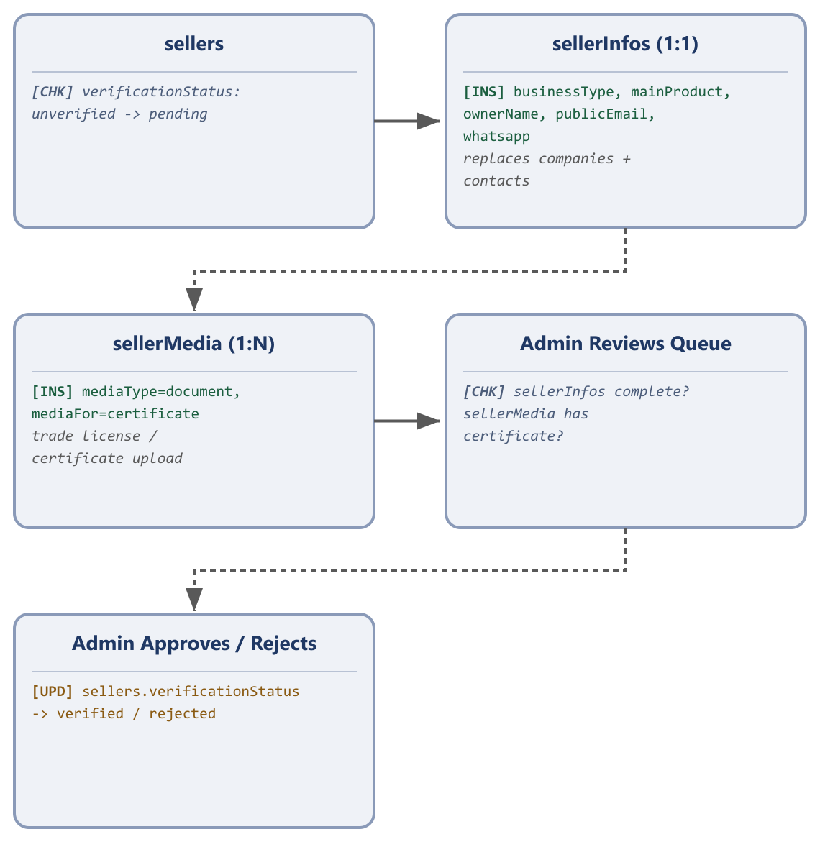
The seller-side upload flow: verification documents and business details.
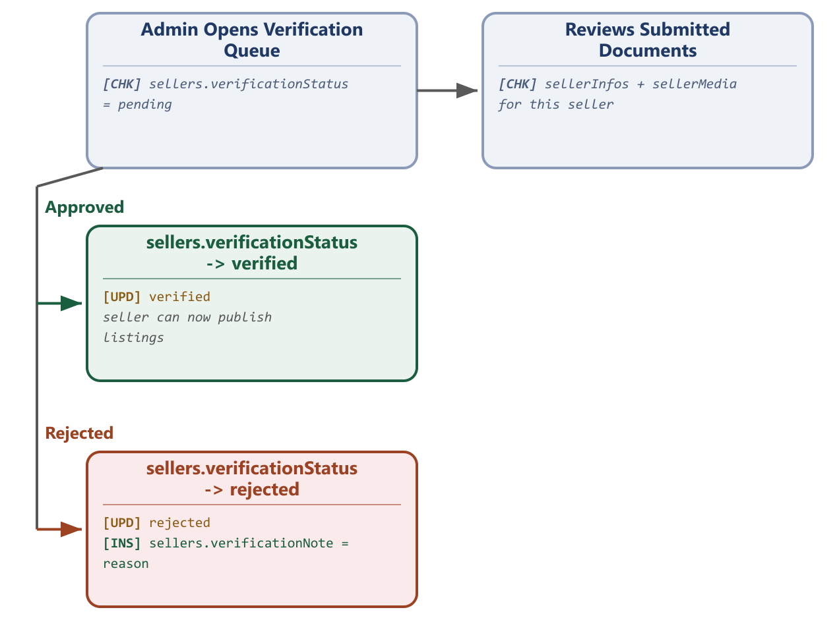
The admin-side view of the same verification workflow.
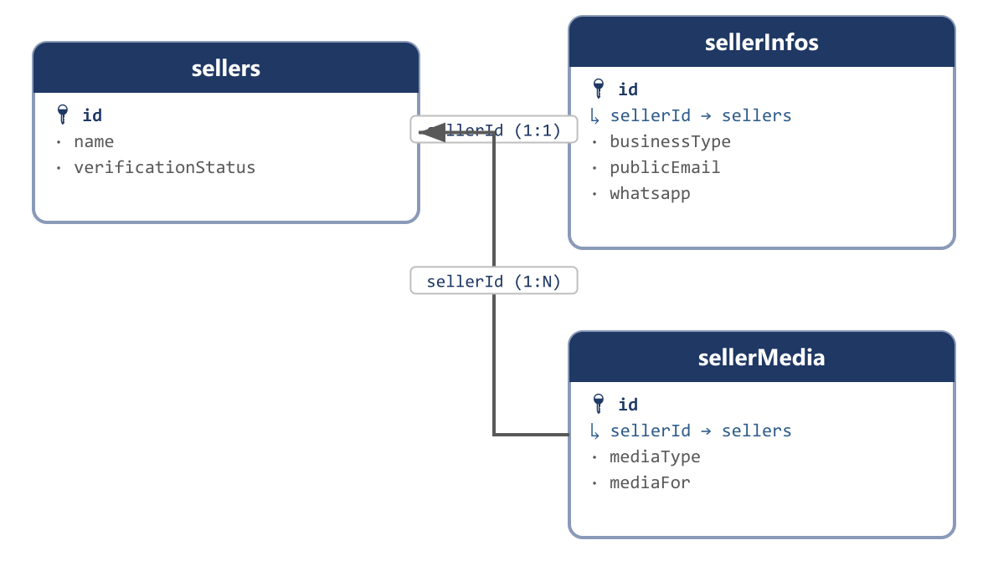
sellerInfos (1:1) and sellerMedia (1:N) both hang off the same sellers row.
Replaces: companies, contacts (folded in), the free-text business columns previously scattered across company_files

sellerInfos
How you reach this table: Reached from Seller Dashboard → Business Profile, filled in any time after signup and required before verificationStatus can move to verified. A seller who skips this step can still log in, but the admin verification queue will reject them for an incomplete profile.
The seller's public-facing business profile — company type, size, and alternate contact channels a buyer might want before messaging through the platform. Legacy companies mapped here already; contacts (whatsapp/facebook/wechat/skype/public email) was documented as folding in here in an earlier revision but never actually given columns — fixed in this revision.
Field | Type | Description | Example
id | bigint PK | Auto-incrementing primary key. | 1
sellerId | bigint FK → sellers, unique | One business profile per seller — enforced as a 1:1 relationship. | 201
businessType | varchar | The category of business this seller runs. | Wholesale Electronics Distributor
mainProduct | varchar | The seller's flagship product or service line. | Mobile phone accessories
ownerName | varchar | Name of the business owner/principal contact. | Rafiqul Islam
employeesRange | varchar | Approximate headcount band, self-reported. | 11-50
annualRevenue | varchar | Approximate annual revenue band, self-reported. | ৳50,00,000 - ৳1,00,00,000
establishedYear | varchar | The year the business was founded. | 2014
description | text, null | Free-text business description shown on the storefront. | Importer and wholesaler of mobile accessories since 2014.
publicEmail | varchar, null | A contact email shown publicly, separate from the private login email on sellers. | contact@rafiqtraders.com
whatsapp | varchar, null | WhatsApp contact number. | +8801711000111
facebook | varchar, null | Facebook page URL. | https://facebook.com/rafiqtraders
wechat | varchar, null | WeChat ID, common for sellers sourcing from Chinese suppliers. | rafiq_traders
skype | varchar, null | Skype ID. | null
countryId | bigint FK → countries, null | Country of the registered business address. | 1
stateId | bigint FK → states, null | State/division of the registered business address. | 1
cityId | bigint FK → cities, null | City/district of the registered business address. | 1
thanaId | bigint FK → thanas, null | Thana/union of the registered business address. | 1
createdBy | bigint, null | ID of the actor who created this row — an admin, seller, or user id depending on creatorType; null when the system created it automatically (e.g. a payment gateway webhook). | 14
creatorType | enum(admin | seller | user | system) | Which actor table createdBy points into. A plain numeric id is ambiguous by itself — admins, sellers and users each have their own id sequence, so id 14 could be any of the three without this column. | seller
creatorName | varchar, null | A denormalized snapshot of the creator's display name at the moment this row was written, so an audit screen can show “Created by Rafiq Traders” without joining three different actor tables. | Rafiq Traders
updatedBy | bigint, null | ID of the actor who last modified this row. Same ambiguity as createdBy, resolved the same way. | 14
updaterType | enum(admin | seller | user | system) | Which actor table updatedBy points into. | seller
updaterName | varchar, null | Denormalized snapshot of the last editor's display name at the time of the edit. | Rafiq Traders
createdAt | timestamp | Row-creation timestamp, maintained automatically by the framework. | 2026-03-14 10:22:00
updatedAt | timestamp | Last-modification timestamp, maintained automatically by the framework. | 2026-03-14 10:22:00
Sample data
Field | Sample Record 1 | Sample Record 2
id | 1 | 2
sellerId | 201 | 202
businessType | Wholesale Electronics Distributor | Retail Electronics Shop
mainProduct | Mobile phone accessories | Smartphones
ownerName | Rafiqul Islam | Kamal Hossain
employeesRange | 11-50 | 1-10
annualRevenue | ৳50,00,000 - ৳1,00,00,000 | ৳10,00,000 - ৳50,00,000
establishedYear | 2014 | 2019
description | Importer and wholesaler of mobile accessories since 2014. | null
publicEmail | contact@rafiqtraders.com | sales@dhakagadget.com
whatsapp | +8801711000111 | +8801711000222
facebook | https://facebook.com/rafiqtraders | null
wechat | rafiq_traders | null
skype | null | null
countryId | 1 | 1
stateId | 1 | 1
cityId | 1 | 1
thanaId | 1 | 1
createdBy | 201 | 202
creatorType | seller | seller
creatorName | Rafiq Traders | Dhaka Gadget House
updatedBy | 201 | 202
updaterType | seller | seller
updaterName | Rafiq Traders | Dhaka Gadget House
createdAt | 2025-01-06 10:00:00 | 2025-03-11 12:00:00
updatedAt | 2025-01-06 10:00:00 | 2025-03-11 12:00:00

3.4 Categories
The legacy schema ran two parallel three-level trees — grand_categories → parent_categories → child_categories for products, and service_grands → service_parents → service_children for services — six structurally identical tables, each hard-capped at exactly three levels. A single self-referencing table with a nullable parentId supports any number of levels — four, five, or more — without another migration, and a type column keeps the product and service trees logically separate within the same table.
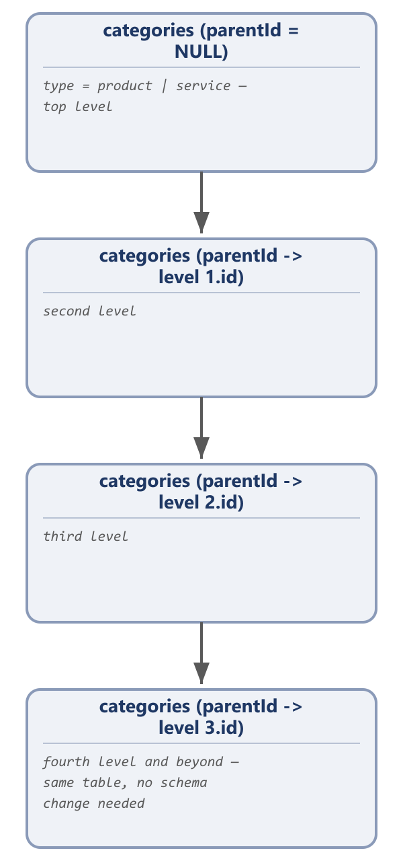
Adjacency-list tree — depth is data, not schema.
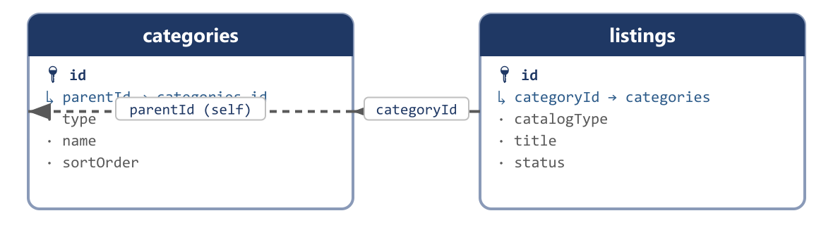
The self-referencing parent/child relationship, plus how a listing points back into the tree.
Replaces: grand_categories, parent_categories, child_categories, service_grands, service_parents, service_children

categories
How you reach this table: Reached only from the admin panel's Category Management screen — an admin creates a top-level category (parentId = null), then adds children underneath it by picking that category as the parent. A seller or buyer never creates a category directly; they only ever select an existing one while creating a listing.
One tree for both products and services, distinguished by type. Depth is data, not schema: MariaDB 11.4 (the live server) supports WITH RECURSIVE for reading the full tree in a single query, so a fifth or sixth level needs no further table changes.
Ambiguous legacy column — confirm before dropping
Legacy grand_categories and service_grands both carry a section tinyint alongside name/path/image, and its exact meaning isn't recoverable from the schema alone — it may simply flag a category as featured/highlighted, or it may scope a category branch to one particular listing format. Check the admin category-management screen before finalizing; this redesign deliberately leaves it out rather than guessing.
Field | Type | Description | Example
id | bigint PK | Auto-incrementing primary key. | 40
parentId | bigint FK → categories.id, null | The parent category; null means this is a top-level category. | null
type | enum(product | service) | Which catalog tree this category belongs to. | product
name | varchar | Category display name (English). | Electronics
nameBn | varchar | Category display name (Bengali), shown when the storefront locale is set to Bangla. | ইলেকট্রনিক্স
slug | varchar, unique | URL-safe identifier derived from name. | electronics
imagePath | varchar, null | Storage path to the category icon. | categories/electronics.png
imageUrl | varchar, null | Public CDN URL for the same icon. | https://cdn.egoola.com/categories/electronics.png
sortOrder | int | Explicit display ordering within the same parent, replacing implicit id order. | 1
status | enum(active | inactive) | Whether listings can currently be assigned to this category. | active
createdBy | bigint, null | ID of the actor who created this row — an admin, seller, or user id depending on creatorType; null when the system created it automatically (e.g. a payment gateway webhook). | 14
creatorType | enum(admin | seller | user | system) | Which actor table createdBy points into. A plain numeric id is ambiguous by itself — admins, sellers and users each have their own id sequence, so id 14 could be any of the three without this column. | seller
creatorName | varchar, null | A denormalized snapshot of the creator's display name at the moment this row was written, so an audit screen can show “Created by Rafiq Traders” without joining three different actor tables. | Rafiq Traders
updatedBy | bigint, null | ID of the actor who last modified this row. Same ambiguity as createdBy, resolved the same way. | 14
updaterType | enum(admin | seller | user | system) | Which actor table updatedBy points into. | seller
updaterName | varchar, null | Denormalized snapshot of the last editor's display name at the time of the edit. | Rafiq Traders
createdAt | timestamp | Row-creation timestamp, maintained automatically by the framework. | 2026-03-14 10:22:00
updatedAt | timestamp | Last-modification timestamp, maintained automatically by the framework. | 2026-03-14 10:22:00
Sample data
Field | Sample Record 1 | Sample Record 2
id | 40 | 44
parentId | null | 40
type | product | product
name | Electronics | Mobile Phones
nameBn | ইলেকট্রনিক্স | মোবাইল ফোন
slug | electronics | mobile-phones
imagePath | categories/electronics.png | categories/mobile-phones.png
imageUrl | https://cdn.egoola.com/categories/electronics.png | https://cdn.egoola.com/categories/mobile-phones.png
sortOrder | 1 | 1
status | active | active
createdBy | 1 | 1
creatorType | admin | admin
creatorName | Super Admin | Super Admin
updatedBy | 1 | 1
updaterType | admin | admin
updaterName | Super Admin | Super Admin
createdAt | 2024-01-03 09:00:00 | 2024-01-03 09:05:00
updatedAt | 2024-01-03 09:00:00 | 2024-01-03 09:05:00

3.5 Catalog / Listings
This is the largest consolidation in the whole redesign. Six listing-format tables (products, used_malls, village_products, retail_shops, wholesales, brand_walls) shared almost the same column set — seller, category, geo, price, approval status — differing mainly in a handful of format-specific fields. The freelance services table (services) was structurally the same idea again: a seller-owned, category-tagged, priced thing for sale. All seven collapse into one listings table with a catalogType (product/service) and, for the product side, a listingType sub-tag preserving which of the old formats a listing came from. Hardcoded tiered-pricing columns become one listingPriceTiers table supporting any number of price breaks, and every listing photo becomes a row in one dedicated listingMedia table owned by a single listingId.
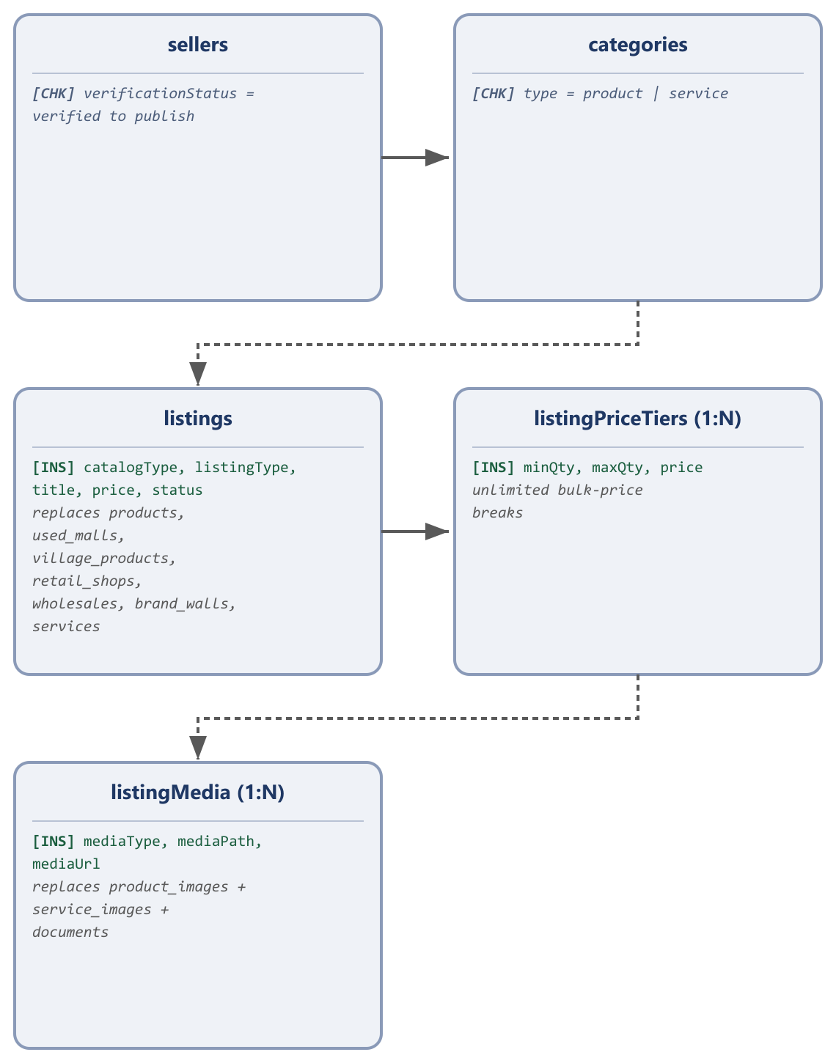
One catalog table for every listing format and for services; unlimited price tiers; one dedicated photo gallery table.
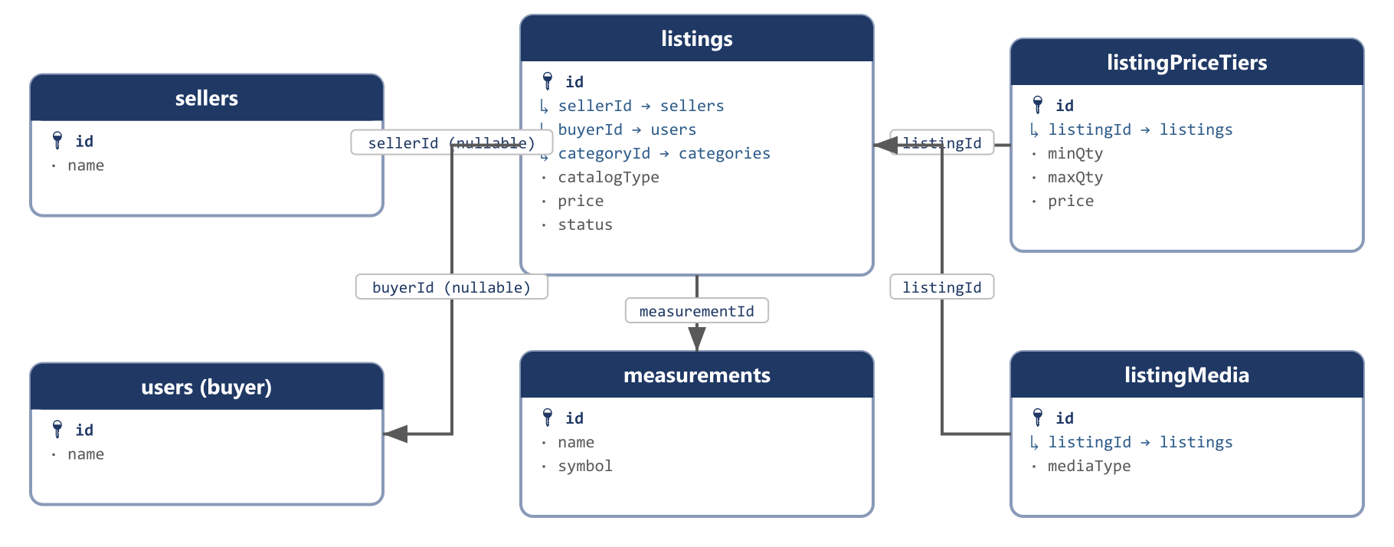
How listings relates to its owner, its category, and its price-tier/media/measurement tables.
Replaces: products, used_malls, village_products, retail_shops, wholesales, brand_walls, services, product_images, service_images, documents

listings
How you reach this table: Reached from Seller Dashboard → Add Listing once a seller's verificationStatus is verified. The seller picks catalogType (product or service) and a matching category, and the form dynamically shows only the fields relevant to that catalogType and listingType. There is one exception: when catalogType = service and postedByRole = buyer_request, the flow starts from the buyer side instead — a buyer opens Post a Job, and this same table receives the row with buyerId set and sellerId left null (see the correctness note below).
The single catalog table behind every product format and every service offer or job request. A row here is not automatically visible to buyers: status must reach approved after admin review before it appears in search or category browsing.
Correctness fix applied during this revision
listings.sellerId was originally drawn as a plain NOT NULL foreign key to sellers, but the buyer-posted-job-request flow (Section 3.6) needs a listing owned by a buyer, not a seller. sellerId is nullable, with a companion buyerId column, and exactly one of the two is set depending on postedByRole.
Field | Type | Description | Example
id | bigint PK | Auto-incrementing primary key. | 3001
sellerId | bigint FK → sellers, null | The catalog owner for every product listing and every seller-posted service offer; null only when postedByRole = buyer_request. | 201
buyerId | bigint FK → users, null | Set only when postedByRole = buyer_request — the buyer who opened this job request; null on every other listing. | null
categoryId | bigint FK → categories | Must match catalogType (a product listing cannot use a service-type category). | 44
catalogType | enum(product | service) | The top-level split this table exists to unify. | product
listingType | enum(general | used | village | retail | wholesale | brand), null | Product side only — records which of the six legacy shop tables this listing's format came from. | general
postedByRole | enum(seller_offer | buyer_request), null | Service side only — replaces services.saler_post. | null
title | varchar | Listing headline. | Samsung Galaxy A15 (Used, Excellent Condition)
slug | varchar, unique | URL-safe identifier derived from title. | samsung-galaxy-a15-used-excellent-condition
description | text | Full listing description. | 128GB, single owner, includes box and charger.
brand | varchar, null | Format-specific, all optional. | Samsung
model | varchar, null | Format-specific. | Galaxy A15
color | varchar, null | Format-specific. | Blue
origin | varchar, null | Format-specific — country of manufacture/import. | South Korea
warranty | varchar, null | Format-specific warranty terms. | No warranty (used item)
price | decimal(10,2) | Base listing price. | 18500.00
oldPrice | decimal(10,2), null | Struck-through original price, for showing a discount. | 21000.00
currency | varchar | Currency code for price/oldPrice. | BDT
priceType | enum(fixed | hourly), null | Service side only. | null
hourlyRate | decimal(10,2), null | Service side only, when priceType = hourly. | null
deliveryDays | int, null | Service side only — turnaround time offered. | null
urgent | boolean, null | Service side only — buyer_request listings flagged as urgent. | null
packageIncludes | text, null | Service side only — what's bundled into the quoted price. | null
availableFrom | timestamp, null | Service side only — start of the project/availability window. | null
availableTo | timestamp, null | Service side only — end of the project/availability window. | null
minOrderQty | int, null | Product side only — minimum purchasable quantity, mainly used by wholesale listings. | 1
stockQty | bigint, null | Product side only — total quantity available. | 40
measurementId | bigint FK → measurements, null | Product side only — the unit stockQty is counted in. | 1
colors | json, null | Product side only — the seller's offered colour options. | ["blue","black"]
sizes | json, null | Product side only — the seller's offered size options. | null
reservedQty | int, null | Product side only — quantity already sold/allocated out of stockQty. | 5
conditionNote | text, null | Product side only — free-text condition/age description, replacing four separate legacy date-part columns. | Used for 8 months, minor scratch on back panel.
attributes | json, null | Catch-all JSON for the remaining format-specific fields the six legacy shop tables didn't share. | {"import":true,"capacity":"128GB"}
countryId | bigint FK → countries, null | Location this listing is offered from. | 1
stateId | bigint FK → states, null | Location this listing is offered from. | 1
cityId | bigint FK → cities, null | Location this listing is offered from. | 1
thanaId | bigint FK → thanas, null | Location this listing is offered from. | 1
status | enum(draft | pending | approved | rejected) | Replaces the approv/approve tinyint duplicated across all six legacy shop tables. | approved
createdBy | bigint, null | ID of the actor who created this row — an admin, seller, or user id depending on creatorType; null when the system created it automatically (e.g. a payment gateway webhook). | 14
creatorType | enum(admin | seller | user | system) | Which actor table createdBy points into. A plain numeric id is ambiguous by itself — admins, sellers and users each have their own id sequence, so id 14 could be any of the three without this column. | seller
creatorName | varchar, null | A denormalized snapshot of the creator's display name at the moment this row was written, so an audit screen can show “Created by Rafiq Traders” without joining three different actor tables. | Rafiq Traders
updatedBy | bigint, null | ID of the actor who last modified this row. Same ambiguity as createdBy, resolved the same way. | 14
updaterType | enum(admin | seller | user | system) | Which actor table updatedBy points into. | seller
updaterName | varchar, null | Denormalized snapshot of the last editor's display name at the time of the edit. | Rafiq Traders
createdAt | timestamp | Row-creation timestamp, maintained automatically by the framework. | 2026-03-14 10:22:00
updatedAt | timestamp | Last-modification timestamp, maintained automatically by the framework. | 2026-03-14 10:22:00
Sample data
Field | Sample Record 1 | Sample Record 2
id | 3001 | 3003
sellerId | 201 | null
buyerId | null | 501
categoryId | 44 | 40
catalogType | product | service
listingType | used | null
postedByRole | null | buyer_request
title | Samsung Galaxy A15 (Used, Excellent Condition) | Need a 3-Bedroom Flat Interior Painter
slug | samsung-galaxy-a15-used-excellent-condition | need-a-3-bedroom-flat-interior-painter
description | 128GB, single owner, includes box and charger. | Looking for an experienced painter for a 3-bedroom flat in Gulshan.
brand | Samsung | null
model | Galaxy A15 | null
color | Blue | null
origin | South Korea | null
warranty | No warranty (used item) | null
price | 18500.00 | null
oldPrice | 21000.00 | null
currency | BDT | BDT
priceType | null | fixed
hourlyRate | null | null
deliveryDays | null | 7
urgent | null | true
packageIncludes | null | null
availableFrom | null | 2026-09-05 00:00:00
availableTo | null | 2026-09-20 00:00:00
minOrderQty | 1 | null
stockQty | 1 | null
measurementId | 1 | null
colors | ["blue"] | null
sizes | null | null
reservedQty | 0 | null
conditionNote | Used for 8 months, minor scratch on back panel. | null
attributes | null | null
countryId | 1 | 1
stateId | 1 | 1
cityId | 1 | 1
thanaId | 1 | 1
status | approved | approved
createdBy | 201 | 501
creatorType | seller | user
creatorName | Rafiq Traders | Mahin Rahman
updatedBy | 201 | 501
updaterType | seller | user
updaterName | Rafiq Traders | Mahin Rahman
createdAt | 2026-06-01 10:00:00 | 2026-08-20 14:30:00
updatedAt | 2026-06-01 10:00:00 | 2026-08-20 14:30:00

listingPriceTiers
How you reach this table: Reached only through its parent listing: while creating or editing a wholesale-type listing, the seller adds one or more “buy N-M units at this price” rows on the same form. A general retail listing typically has zero rows here and just uses listings.price directly.
Unlimited bulk-pricing tiers per listing, replacing the legacy hardcoded columns (wholesales.first/second/third_quantity[_price], products.price_1/2/piece_1/2/3) that capped every listing at exactly three price breaks.
Field | Type | Description | Example
id | bigint PK | Auto-incrementing primary key. | 1
listingId | bigint FK → listings | The listing this price tier belongs to. | 3001
minQty | int | Minimum quantity to qualify for this tier. | 10
maxQty | int, null | Maximum quantity for this tier; null means this is the unbounded top tier. | 49
price | decimal(10,2) | Per-unit price at this quantity tier. | 17800.00
createdBy | bigint, null | ID of the actor who created this row — an admin, seller, or user id depending on creatorType; null when the system created it automatically (e.g. a payment gateway webhook). | 14
creatorType | enum(admin | seller | user | system) | Which actor table createdBy points into. A plain numeric id is ambiguous by itself — admins, sellers and users each have their own id sequence, so id 14 could be any of the three without this column. | seller
creatorName | varchar, null | A denormalized snapshot of the creator's display name at the moment this row was written, so an audit screen can show “Created by Rafiq Traders” without joining three different actor tables. | Rafiq Traders
updatedBy | bigint, null | ID of the actor who last modified this row. Same ambiguity as createdBy, resolved the same way. | 14
updaterType | enum(admin | seller | user | system) | Which actor table updatedBy points into. | seller
updaterName | varchar, null | Denormalized snapshot of the last editor's display name at the time of the edit. | Rafiq Traders
createdAt | timestamp | Row-creation timestamp, maintained automatically by the framework. | 2026-03-14 10:22:00
updatedAt | timestamp | Last-modification timestamp, maintained automatically by the framework. | 2026-03-14 10:22:00
Sample data
Field | Sample Record 1 | Sample Record 2
id | 1 | 2
listingId | 3001 | 3001
minQty | 10 | 50
maxQty | 49 | null
price | 17800.00 | 17200.00
createdBy | 201 | 201
creatorType | seller | seller
creatorName | Rafiq Traders | Rafiq Traders
updatedBy | 201 | 201
updaterType | seller | seller
updaterName | Rafiq Traders | Rafiq Traders
createdAt | 2026-06-01 10:02:00 | 2026-06-01 10:02:00
updatedAt | 2026-06-01 10:02:00 | 2026-06-01 10:02:00

listingMedia
How you reach this table: Reached only through its parent listing: every photo, video, or attachment added while creating or editing a listing becomes one row here. This is also where the legacy brand-wall document attachment lands — it turned out to be a per-listing file, not a seller-level one (see the correction note below).
One dedicated photo/video/document gallery for every listing, whatever its catalogType or listingType. Since products and services now share the same listings table, the gallery table takes its name from the table it belongs to — listingMedia — so a service's portfolio images and a product's photos both live in the same, correctly-named table.
Correction applied during an earlier revision
documents was mapped to sellerMedia in an earlier pass, on the assumption it was a company-level upload. Re-checking the legacy schema directly: documents.brand_wall_id points at a specific brand_walls listing, not at a seller — it is a per-listing attachment (used only by the brand-wall format), not a seller-level one. It belongs in listingMedia (mediaType = document), not sellerMedia.
Field | Type | Description | Example
id | bigint PK | Auto-incrementing primary key. | 1
listingId | bigint FK → listings | The listing this file belongs to — a typed, single-owner foreign key, not a polymorphic pairing. | 3001
mediaType | enum(image | video | document) | Replaces product_images.what and documents (brand-wall attachments). | image
mediaPath | varchar | Storage path/disk key the app writes to and reads from. | listings/3001/photo-1.jpg
mediaUrl | varchar | Public/CDN URL served to the browser. | https://cdn.egoola.com/listings/3001/photo-1.jpg
createdBy | bigint, null | ID of the actor who created this row — an admin, seller, or user id depending on creatorType; null when the system created it automatically (e.g. a payment gateway webhook). | 14
creatorType | enum(admin | seller | user | system) | Which actor table createdBy points into. A plain numeric id is ambiguous by itself — admins, sellers and users each have their own id sequence, so id 14 could be any of the three without this column. | seller
creatorName | varchar, null | A denormalized snapshot of the creator's display name at the moment this row was written, so an audit screen can show “Created by Rafiq Traders” without joining three different actor tables. | Rafiq Traders
updatedBy | bigint, null | ID of the actor who last modified this row. Same ambiguity as createdBy, resolved the same way. | 14
updaterType | enum(admin | seller | user | system) | Which actor table updatedBy points into. | seller
updaterName | varchar, null | Denormalized snapshot of the last editor's display name at the time of the edit. | Rafiq Traders
createdAt | timestamp | Row-creation timestamp, maintained automatically by the framework. | 2026-03-14 10:22:00
updatedAt | timestamp | Last-modification timestamp, maintained automatically by the framework. | 2026-03-14 10:22:00
Sample data
Field | Sample Record 1 | Sample Record 2
id | 1 | 2
listingId | 3001 | 3001
mediaType | image | image
mediaPath | listings/3001/photo-1.jpg | listings/3001/photo-2.jpg
mediaUrl | https://cdn.egoola.com/listings/3001/photo-1.jpg | https://cdn.egoola.com/listings/3001/photo-2.jpg
createdBy | 201 | 201
creatorType | seller | seller
creatorName | Rafiq Traders | Rafiq Traders
updatedBy | 201 | 201
updaterType | seller | seller
updaterName | Rafiq Traders | Rafiq Traders
createdAt | 2026-06-01 10:01:00 | 2026-06-01 10:01:30
updatedAt | 2026-06-01 10:01:00 | 2026-06-01 10:01:30

measurements
How you reach this table: Reached only from the admin panel's unit-of-measure settings screen. Sellers never create a measurement directly — they only pick one from this list while adding a product listing that tracks stockQty.
A small, admin-maintained lookup of stock units (kept unchanged from the legacy schema), referenced by listings.measurementId.
Field | Type | Description | Example
id | bigint PK | Auto-incrementing primary key. | 1
name | varchar | Full unit name. | Kilogram
symbol | varchar | Short display symbol. | Kg
createdBy | bigint, null | ID of the actor who created this row — an admin, seller, or user id depending on creatorType; null when the system created it automatically (e.g. a payment gateway webhook). | 14
creatorType | enum(admin | seller | user | system) | Which actor table createdBy points into. A plain numeric id is ambiguous by itself — admins, sellers and users each have their own id sequence, so id 14 could be any of the three without this column. | seller
creatorName | varchar, null | A denormalized snapshot of the creator's display name at the moment this row was written, so an audit screen can show “Created by Rafiq Traders” without joining three different actor tables. | Rafiq Traders
updatedBy | bigint, null | ID of the actor who last modified this row. Same ambiguity as createdBy, resolved the same way. | 14
updaterType | enum(admin | seller | user | system) | Which actor table updatedBy points into. | seller
updaterName | varchar, null | Denormalized snapshot of the last editor's display name at the time of the edit. | Rafiq Traders
createdAt | timestamp | Row-creation timestamp, maintained automatically by the framework. | 2026-03-14 10:22:00
updatedAt | timestamp | Last-modification timestamp, maintained automatically by the framework. | 2026-03-14 10:22:00
Sample data
Field | Sample Record 1 | Sample Record 2
id | 1 | 2
name | Piece | Kilogram
symbol | Pcs | Kg
createdBy | 1 | 1
creatorType | admin | admin
creatorName | Super Admin | Super Admin
updatedBy | 1 | 1
updaterType | admin | admin
updaterName | Super Admin | Super Admin
createdAt | 2024-01-01 00:00:00 | 2024-01-01 00:00:00
updatedAt | 2024-01-01 00:00:00 | 2024-01-01 00:00:00

3.6 Bidding, Hiring & the Job/Order Merge
The platform audit found the direct-hire path (service_orders) and the bid-then-hire path (bid_for_services → hireds) were two separately-coded implementations of the same idea, and they had drifted apart: different cancel-guard bugs, and bid-hire earnings never reaching the seller's withdrawal ledger at all. The redesign keeps exactly one bids table for the negotiation step; both a direct hire and an accepted bid produce the same kind of row in the unified orders table (Section 3.7) — one status state machine, one commission calculation, one payout path, for both.
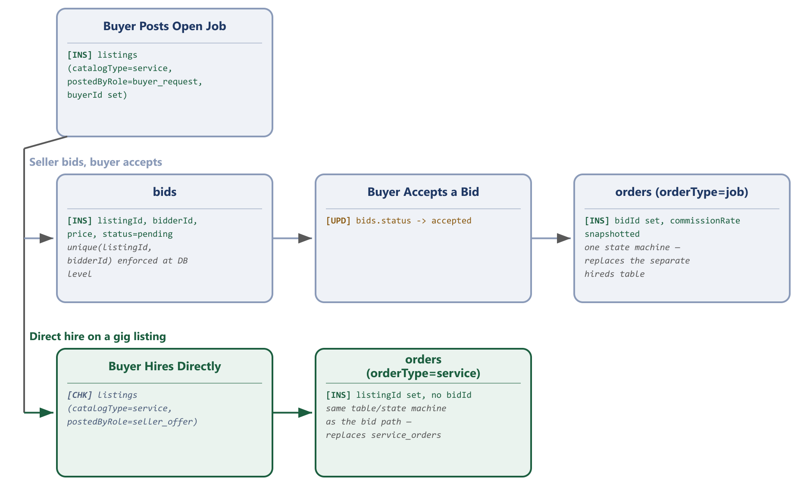
Two ways to start a job, one order pipeline to finish it.
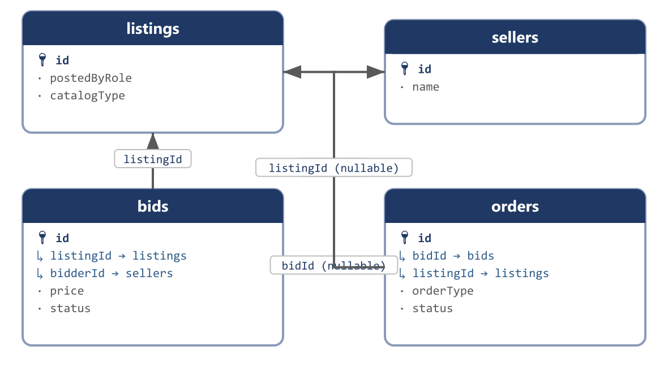
A bid references a listing and a bidder; an accepted bid produces an order.
Replaces: bid_for_services, hireds, hire_pays, service_orders, order_pays (service side)

bids
How you reach this table: Reached from a buyer's job-request listing (listings.postedByRole = buyer_request): any verified seller who wants the work opens that listing and clicks Submit a Bid, filling in price, timeline and a short pitch. The buyer then reviews every bid submitted against their job and accepts one, which triggers order creation (Section 3.7).
The one negotiation table behind every hire, whether it started as a buyer's open job request or a seller reaching out to bid on one.
Bug fixed at the schema level
A unique constraint on (listingId, bidderId) enforces one-bid-per-project in the database itself. Today it is only checked in application code, so a race condition or a missed code path could let a seller submit two competing bids on the same job.
Field | Type | Description | Example
id | bigint PK | Auto-incrementing primary key. | 7001
listingId | bigint FK → listings | The job/service being bid on. | 3003
bidderId | bigint FK → sellers | The seller placing the bid. | 202
priceType | enum(fixed | hourly) | How this bid is priced. | fixed
price | decimal(10,2), null | Fixed-price bid amount, when priceType = fixed. | 12000.00
hourlyRate | decimal(10,2), null | Hourly rate, when priceType = hourly. | null
hours | int, null | Estimated hours, when priceType = hourly. | null
description | varchar(300) | The bidder's pitch — a unified length limit, closing a 60-vs-30-character mismatch between the two legacy submission forms. | Experienced interior painter, can start this weekend, materials included.
proposedStart | timestamp, null | Proposed project start date. | 2026-09-06 09:00:00
proposedEnd | timestamp, null | Proposed project completion date. | 2026-09-10 18:00:00
status | enum(pending | accepted | rejected | withdrawn) | Current state of this bid. | accepted
createdBy | bigint, null | ID of the actor who created this row — an admin, seller, or user id depending on creatorType; null when the system created it automatically (e.g. a payment gateway webhook). | 14
creatorType | enum(admin | seller | user | system) | Which actor table createdBy points into. A plain numeric id is ambiguous by itself — admins, sellers and users each have their own id sequence, so id 14 could be any of the three without this column. | seller
creatorName | varchar, null | A denormalized snapshot of the creator's display name at the moment this row was written, so an audit screen can show “Created by Rafiq Traders” without joining three different actor tables. | Rafiq Traders
updatedBy | bigint, null | ID of the actor who last modified this row. Same ambiguity as createdBy, resolved the same way. | 14
updaterType | enum(admin | seller | user | system) | Which actor table updatedBy points into. | seller
updaterName | varchar, null | Denormalized snapshot of the last editor's display name at the time of the edit. | Rafiq Traders
createdAt | timestamp | Row-creation timestamp, maintained automatically by the framework. | 2026-03-14 10:22:00
updatedAt | timestamp | Last-modification timestamp, maintained automatically by the framework. | 2026-03-14 10:22:00
Sample data
Field | Sample Record 1 | Sample Record 2
id | 7001 | 7002
listingId | 3003 | 3003
bidderId | 202 | 201
priceType | fixed | hourly
price | 12000.00 | null
hourlyRate | null | 600.00
hours | null | 20
description | Experienced interior painter, can start this weekend, materials included. | Team of 2 painters available, flexible schedule.
proposedStart | 2026-09-06 09:00:00 | 2026-09-08 09:00:00
proposedEnd | 2026-09-10 18:00:00 | 2026-09-12 18:00:00
status | accepted | rejected
createdBy | 202 | 201
creatorType | seller | seller
creatorName | Dhaka Gadget House | Rafiq Traders
updatedBy | 202 | 201
updaterType | seller | seller
updaterName | Dhaka Gadget House | Rafiq Traders
createdAt | 2026-08-21 08:00:00 | 2026-08-21 09:30:00
updatedAt | 2026-08-21 08:00:00 | 2026-08-21 09:30:00

3.7 Orders, Order Items & Payments
Every purchase flow — buying physical goods, hiring a service, or accepting a job bid — collapses around three core tables: orders (the transaction envelope, tagged by orderType), orderItems (the line items within it), and payments (every money movement against it, tagged by purpose), with carts/cartItems feeding into orders/orderItems at checkout using the same header/line-item pattern. This design replaces fourteen legacy tables: the physical-goods path (sales, orders, billings, shippings, delivery_costs, order_pays), the service/job path (service_orders, hireds, hire_pays), and the entire wallet/withdrawal side (payments, payment_requests, balances, refund_histories, transactions, commissions, commission_payments, seller_payments).
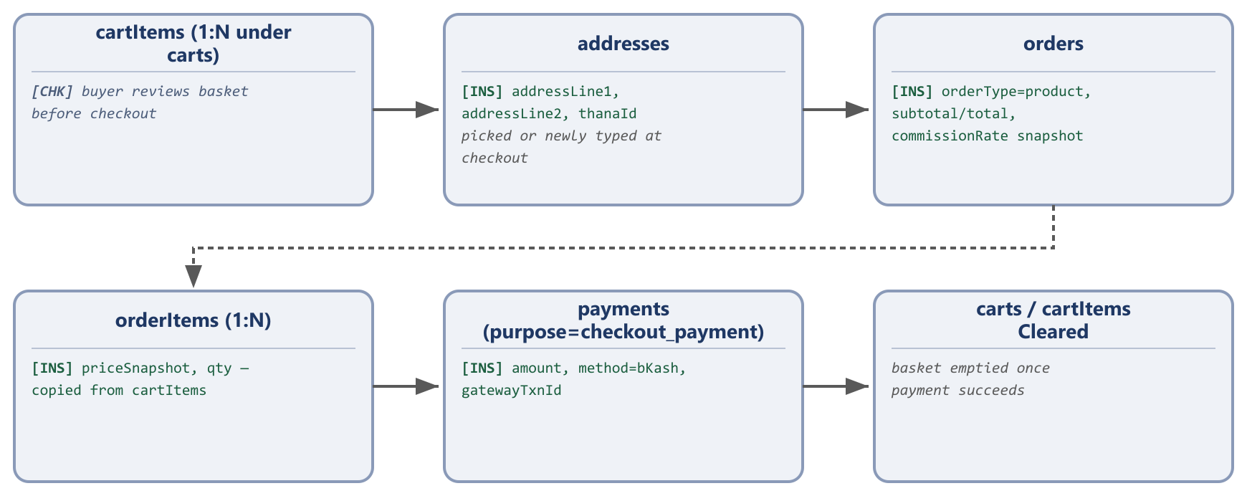
Cart to order to payment, step by step.
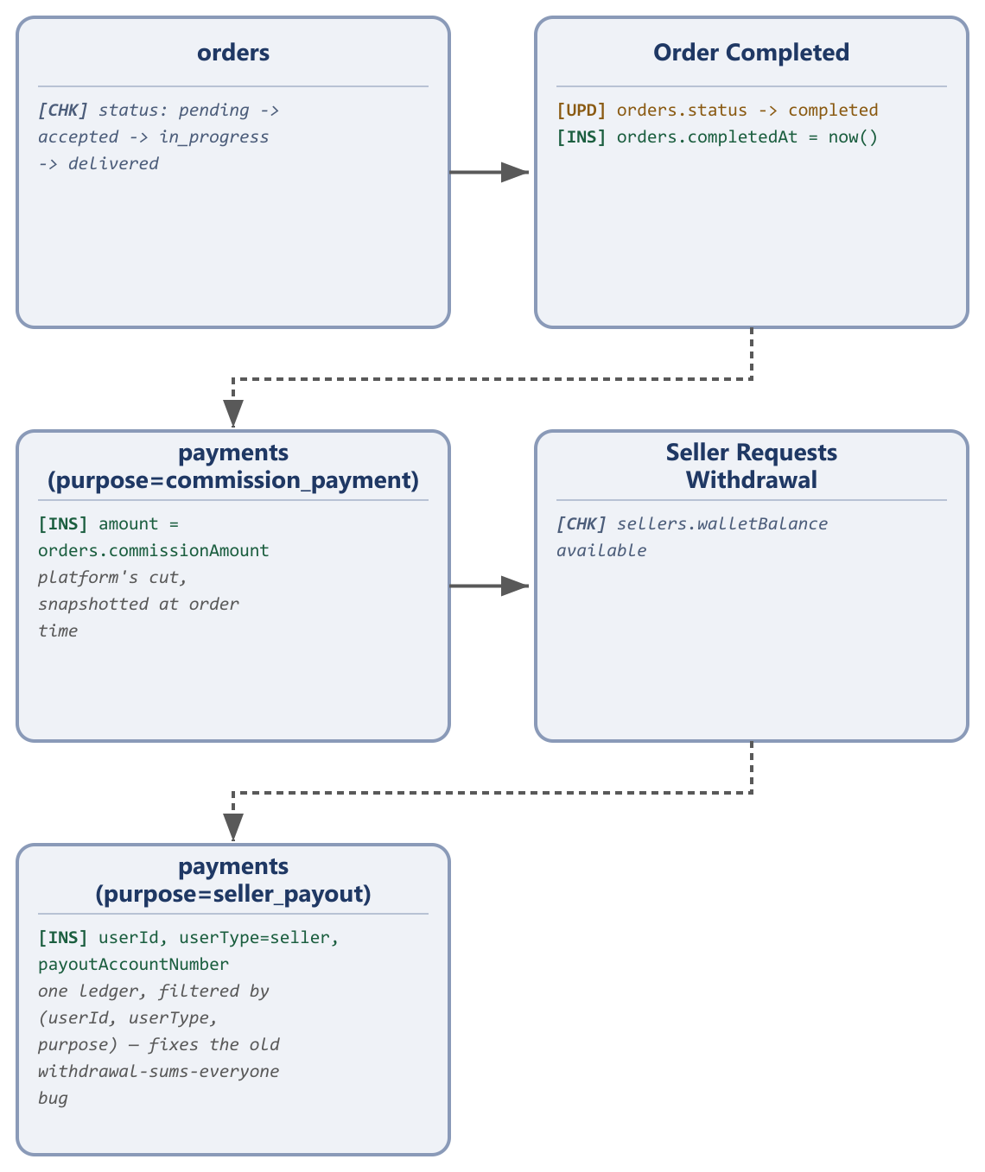
The full order lifecycle, including commission capture and seller payout.
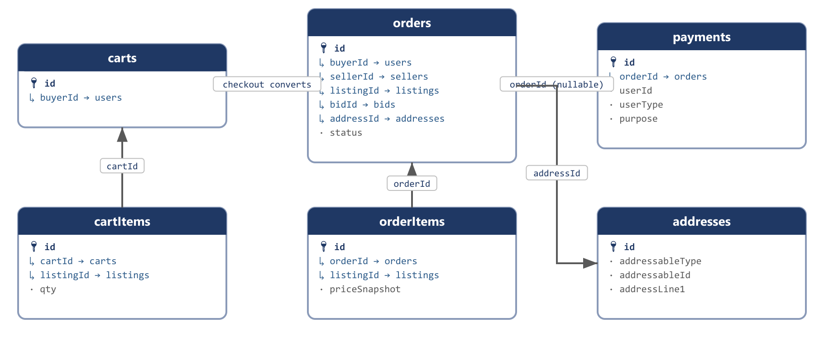
How carts, orders, order items, payments and addresses connect to each other.
Replaces: carts (kept, split into a header + items pair), sales, orders, billings, shippings, delivery_costs, order_pays, service_orders, hireds, hire_pays, payments, payment_requests, balances, refund_histories, transactions, commissions, commission_payments, seller_payments

carts (header)
How you reach this table: Created automatically the first time a signed-in buyer adds any listing to their basket — one row per buyer, reused for every subsequent add until checkout clears it.
A thin header row: one open cart per buyer, holding no line-item data itself. Pre-checkout staging only — rows convert into an order plus its orderItems at checkout and are then cleared, rather than being repurposed as historical order data the way sales currently is.
Field | Type | Description | Example
id | bigint PK | Auto-incrementing primary key. | 1
buyerId | bigint FK → users, unique | One open cart per buyer. | 501
createdBy | bigint, null | ID of the actor who created this row — an admin, seller, or user id depending on creatorType; null when the system created it automatically (e.g. a payment gateway webhook). | 14
creatorType | enum(admin | seller | user | system) | Which actor table createdBy points into. A plain numeric id is ambiguous by itself — admins, sellers and users each have their own id sequence, so id 14 could be any of the three without this column. | seller
creatorName | varchar, null | A denormalized snapshot of the creator's display name at the moment this row was written, so an audit screen can show “Created by Rafiq Traders” without joining three different actor tables. | Rafiq Traders
updatedBy | bigint, null | ID of the actor who last modified this row. Same ambiguity as createdBy, resolved the same way. | 14
updaterType | enum(admin | seller | user | system) | Which actor table updatedBy points into. | seller
updaterName | varchar, null | Denormalized snapshot of the last editor's display name at the time of the edit. | Rafiq Traders
createdAt | timestamp | Row-creation timestamp, maintained automatically by the framework. | 2026-03-14 10:22:00
updatedAt | timestamp | Last-modification timestamp, maintained automatically by the framework. | 2026-03-14 10:22:00
Sample data
Field | Sample Record 1
id | 1
buyerId | 501
createdBy | 501
creatorType | user
creatorName | Mahin Rahman
updatedBy | 501
updaterType | user
updaterName | Mahin Rahman
createdAt | 2026-08-25 18:00:00
updatedAt | 2026-08-25 18:00:00

cartItems
How you reach this table: Reached only through its parent cart: clicking Add to Cart on a listing inserts one row here (or increments qty on an existing row for the same listing/color/size combination).
Line items under a cart — the same header/line-item shape as orders/orderItems below it, so a buyer with several different listings in their basket has several cartItems rows under one carts row, instead of several standalone cart rows with no shared parent.
Field | Type | Description | Example
id | bigint PK | Auto-incrementing primary key. | 1
cartId | bigint FK → carts | The cart this item belongs to. | 1
listingId | bigint FK → listings | The listing added to the basket. | 3001
qty | int | Quantity of this listing in the basket. | 1
color | varchar, null | Selected colour variant, if the listing offers one. | Blue
size | varchar, null | Selected size variant, if the listing offers one. | null
createdBy | bigint, null | ID of the actor who created this row — an admin, seller, or user id depending on creatorType; null when the system created it automatically (e.g. a payment gateway webhook). | 14
creatorType | enum(admin | seller | user | system) | Which actor table createdBy points into. A plain numeric id is ambiguous by itself — admins, sellers and users each have their own id sequence, so id 14 could be any of the three without this column. | seller
creatorName | varchar, null | A denormalized snapshot of the creator's display name at the moment this row was written, so an audit screen can show “Created by Rafiq Traders” without joining three different actor tables. | Rafiq Traders
updatedBy | bigint, null | ID of the actor who last modified this row. Same ambiguity as createdBy, resolved the same way. | 14
updaterType | enum(admin | seller | user | system) | Which actor table updatedBy points into. | seller
updaterName | varchar, null | Denormalized snapshot of the last editor's display name at the time of the edit. | Rafiq Traders
createdAt | timestamp | Row-creation timestamp, maintained automatically by the framework. | 2026-03-14 10:22:00
updatedAt | timestamp | Last-modification timestamp, maintained automatically by the framework. | 2026-03-14 10:22:00
Sample data
Field | Sample Record 1
id | 1
cartId | 1
listingId | 3001
qty | 1
color | Blue
size | null
createdBy | 501
creatorType | user
creatorName | Mahin Rahman
updatedBy | 501
updaterType | user
updaterName | Mahin Rahman
createdAt | 2026-08-25 18:00:00
updatedAt | 2026-08-25 18:00:00

orders
How you reach this table: Reached from checkout (a cart converts into an order once the buyer confirms payment) or from Section 3.6 (an accepted bid converts into an order automatically). Both paths land in this same table with the same status state machine — orderType is the only thing that varies.
The transaction envelope shared by every purchase, hire, or completed job. One state machine replaces the ad hoc accept tinyint codes — including a documented operator-precedence cancel-guard bug — previously duplicated across service_orders and hireds.
Field | Type | Description | Example
id | bigint PK | Auto-incrementing primary key. | 9001
buyerId | bigint FK → users | The buyer on this order. | 501
sellerId | bigint FK → sellers | The seller on this order. | 201
orderType | enum(product | service | job) | Which purchase flow produced this order. | product
listingId | bigint FK → listings, null | Set for direct product/service orders. | 3001
bidId | bigint FK → bids, null | Set when the order came from an accepted bid. | null
addressId | bigint FK → addresses, null | Delivery address, product orders only. | 1
status | enum(pending | accepted | in_progress | delivered | completed | cancelled | disputed) | Current stage of the order. | completed
subtotal | decimal(10,2) | Sum of order-item subtotals before delivery/discount. | 18500.00
deliveryCost | decimal(10,2) | Shipping/delivery fee charged. | 80.00
discount | decimal(10,2) | Discount applied. | 0.00
total | decimal(10,2) | Final charged amount. | 18580.00
commissionRate | decimal(5,2) | Platform commission percentage, snapshotted at order time — replaces a hardcoded 20% in application code. | 10.00
commissionAmount | decimal(10,2) | Commission amount in currency, computed from commissionRate at order time. | 1850.00
expectedDeliveryAt | timestamp, null | Estimated delivery/completion date shown to the buyer. | 2026-08-28 00:00:00
completedAt | timestamp, null | When status reached completed. | 2026-08-27 15:20:00
cancelledReason | text, null | Reason recorded if the order was cancelled. | null
confirmationSecret | varchar, null | The delivery-confirmation token used to mark an order received; kept here so the previously-audited missing-email bug is purely an application-code fix once this migration lands. | c9f1a2e7b3
createdBy | bigint, null | ID of the actor who created this row — an admin, seller, or user id depending on creatorType; null when the system created it automatically (e.g. a payment gateway webhook). | 14
creatorType | enum(admin | seller | user | system) | Which actor table createdBy points into. A plain numeric id is ambiguous by itself — admins, sellers and users each have their own id sequence, so id 14 could be any of the three without this column. | seller
creatorName | varchar, null | A denormalized snapshot of the creator's display name at the moment this row was written, so an audit screen can show “Created by Rafiq Traders” without joining three different actor tables. | Rafiq Traders
updatedBy | bigint, null | ID of the actor who last modified this row. Same ambiguity as createdBy, resolved the same way. | 14
updaterType | enum(admin | seller | user | system) | Which actor table updatedBy points into. | seller
updaterName | varchar, null | Denormalized snapshot of the last editor's display name at the time of the edit. | Rafiq Traders
createdAt | timestamp | Row-creation timestamp, maintained automatically by the framework. | 2026-03-14 10:22:00
updatedAt | timestamp | Last-modification timestamp, maintained automatically by the framework. | 2026-03-14 10:22:00
Sample data
Field | Sample Record 1 | Sample Record 2
id | 9001 | 9002
buyerId | 501 | 502
sellerId | 201 | 202
orderType | product | job
listingId | 3001 | null
bidId | null | 7001
addressId | 1 | null
status | completed | in_progress
subtotal | 18500.00 | 12000.00
deliveryCost | 80.00 | 0.00
discount | 0.00 | 0.00
total | 18580.00 | 12000.00
commissionRate | 10.00 | 10.00
commissionAmount | 1850.00 | 1200.00
expectedDeliveryAt | 2026-08-28 00:00:00 | 2026-09-10 18:00:00
completedAt | 2026-08-27 15:20:00 | null
cancelledReason | null | null
confirmationSecret | c9f1a2e7b3 | a7e2b9c4d1
createdBy | 501 | 502
creatorType | user | user
creatorName | Mahin Rahman | Sumaiya Akter
updatedBy | 501 | 502
updaterType | user | user
updaterName | Mahin Rahman | Sumaiya Akter
createdAt | 2026-08-25 18:10:00 | 2026-08-21 10:00:00
updatedAt | 2026-08-25 18:10:00 | 2026-08-21 10:00:00

orderItems
How you reach this table: Reached only through its parent order: created automatically when a cart converts to an order (one row per cartItems row) or when a bid converts to an order (one row summarizing the accepted bid).
Line items within an order, with pricing snapshotted at purchase time so a later listing edit never rewrites the historical record of what was actually bought.
Field | Type | Description | Example
id | bigint PK | Auto-incrementing primary key. | 1
orderId | bigint FK → orders | The order this item belongs to. | 9001
listingId | bigint FK → listings | The listing purchased. | 3001
titleSnapshot | varchar | Listing title captured at purchase time. | Samsung Galaxy A15 (Used, Excellent Condition)
priceSnapshot | decimal(10,2) | Unit price captured at purchase time. | 18500.00
qty | int | Quantity purchased. | 1
color | varchar, null | Selected colour variant. | Blue
size | varchar, null | Selected size variant. | null
status | enum(pending | shipped | delivered), null | Per-item delivery status — only needed if items in the same order can ship separately; confirm this still happens before dropping it in favor of the order-level status alone. | delivered
deliverablePath | varchar, null | Service/job order items only — the seller's uploaded completed-work file. | null
subtotal | decimal(10,2) | priceSnapshot × qty. | 18500.00
createdBy | bigint, null | ID of the actor who created this row — an admin, seller, or user id depending on creatorType; null when the system created it automatically (e.g. a payment gateway webhook). | 14
creatorType | enum(admin | seller | user | system) | Which actor table createdBy points into. A plain numeric id is ambiguous by itself — admins, sellers and users each have their own id sequence, so id 14 could be any of the three without this column. | seller
creatorName | varchar, null | A denormalized snapshot of the creator's display name at the moment this row was written, so an audit screen can show “Created by Rafiq Traders” without joining three different actor tables. | Rafiq Traders
updatedBy | bigint, null | ID of the actor who last modified this row. Same ambiguity as createdBy, resolved the same way. | 14
updaterType | enum(admin | seller | user | system) | Which actor table updatedBy points into. | seller
updaterName | varchar, null | Denormalized snapshot of the last editor's display name at the time of the edit. | Rafiq Traders
createdAt | timestamp | Row-creation timestamp, maintained automatically by the framework. | 2026-03-14 10:22:00
updatedAt | timestamp | Last-modification timestamp, maintained automatically by the framework. | 2026-03-14 10:22:00
Sample data
Field | Sample Record 1 | Sample Record 2
id | 1 | 2
orderId | 9001 | 9002
listingId | 3001 | 3003
titleSnapshot | Samsung Galaxy A15 (Used, Excellent Condition) | Need a 3-Bedroom Flat Interior Painter
priceSnapshot | 18500.00 | 12000.00
qty | 1 | 1
color | Blue | null
size | null | null
status | delivered | null
deliverablePath | null | null
subtotal | 18500.00 | 12000.00
createdBy | 501 | 502
creatorType | user | user
creatorName | Mahin Rahman | Sumaiya Akter
updatedBy | 501 | 502
updaterType | user | user
updaterName | Mahin Rahman | Sumaiya Akter
createdAt | 2026-08-25 18:10:00 | 2026-08-21 10:00:00
updatedAt | 2026-08-25 18:10:00 | 2026-08-21 10:00:00

payments
How you reach this table: Reached from two different directions: a checkout_payment row is written the moment a buyer completes payment on an order; a seller_payout row is written when a seller requests a withdrawal from Seller Dashboard → Wallet, and a commission_payment/refund row is written by the platform's own settlement/refund process. All four purposes share this one ledger.
Every money movement against an order, or a standalone seller withdrawal, in one auditable ledger filtered by purpose instead of scattered across seven legacy tables.
Bug fixed at the schema level
Filtering payments by (userId, userType, purpose = seller_payout) is a normal indexed query, replacing the legacy withdrawal calculation that summed every seller's completed payouts together instead of just the current user's. The same table also closes the earnings-ledger asymmetry: because both the direct-hire and bid-hire paths now produce the same kind of order, there is only one payout code path.
Field | Type | Description | Example
id | bigint PK | Auto-incrementing primary key. | 1
orderId | bigint FK → orders, null | Null for a standalone withdrawal not tied to one order. | 9001
userId | bigint | The buyer paying in, or the seller withdrawing. | 501
userType | enum(seller | user) | Which actor table userId points into — added in this revision so the reference is no longer ambiguous. | user
purpose | enum(checkout_payment | seller_payout | commission_payment | refund) | What this money movement is for. | checkout_payment
direction | enum(credit | debit) | Supports one running ledger per user. | debit
amount | decimal(10,2) | Amount moved. | 18580.00
method | varchar | Payment channel used. | bKash
gatewayTxnId | varchar, null | Transaction id returned by bKash/Stripe/bank. | TRX8F2C91
payoutAccountNumber | varchar, null | seller_payout rows only — the destination bKash/bank account for the withdrawal. | null
status | enum(pending | completed | failed | refunded) | Current state of this payment. | completed
meta | json, null | Raw gateway response, kept for reconciliation. | {"gateway":"bkash","fee":"0.00"}
createdBy | bigint, null | ID of the actor who created this row — an admin, seller, or user id depending on creatorType; null when the system created it automatically (e.g. a payment gateway webhook). | 14
creatorType | enum(admin | seller | user | system) | Which actor table createdBy points into. A plain numeric id is ambiguous by itself — admins, sellers and users each have their own id sequence, so id 14 could be any of the three without this column. | seller
creatorName | varchar, null | A denormalized snapshot of the creator's display name at the moment this row was written, so an audit screen can show “Created by Rafiq Traders” without joining three different actor tables. | Rafiq Traders
updatedBy | bigint, null | ID of the actor who last modified this row. Same ambiguity as createdBy, resolved the same way. | 14
updaterType | enum(admin | seller | user | system) | Which actor table updatedBy points into. | seller
updaterName | varchar, null | Denormalized snapshot of the last editor's display name at the time of the edit. | Rafiq Traders
createdAt | timestamp | Row-creation timestamp, maintained automatically by the framework. | 2026-03-14 10:22:00
updatedAt | timestamp | Last-modification timestamp, maintained automatically by the framework. | 2026-03-14 10:22:00
Sample data
Field | Sample Record 1 | Sample Record 2
id | 1 | 2
orderId | 9001 | null
userId | 501 | 201
userType | user | seller
purpose | checkout_payment | seller_payout
direction | debit | credit
amount | 18580.00 | 5000.00
method | bKash | bank
gatewayTxnId | TRX8F2C91 | PYT2C7A44
payoutAccountNumber | null | 1234567890123
status | completed | pending
meta | {"gateway":"bkash","fee":"0.00"} | null
createdBy | null | 201
creatorType | system | seller
creatorName | bKash Webhook | Rafiq Traders
updatedBy | null | 201
updaterType | system | seller
updaterName | bKash Webhook | Rafiq Traders
createdAt | 2026-08-25 18:11:00 | 2026-08-30 09:00:00
updatedAt | 2026-08-25 18:11:00 | 2026-08-30 09:00:00

addresses
How you reach this table: Reached at checkout, when a buyer either picks a previously saved address or types a new one, and again from the buyer's own Address Book screen for managing saved addresses outside of checkout.
A delivery-address snapshot, either attached to one specific order or saved standalone against a buyer for reuse at a future checkout.
Field | Type | Description | Example
id | bigint PK | Auto-incrementing primary key. | 1
addressableType | enum(order | user) | Whether this address belongs to one specific order or is a buyer's saved address. | user
addressableId | bigint | The order id or user id this address belongs to, depending on addressableType. | 501
name | varchar | Recipient name. | Mahin Rahman
phone | varchar | Recipient phone number. | +8801911222333
countryId | bigint FK → countries | Delivery country. | 1
stateId | bigint FK → states | Delivery state/division. | 1
cityId | bigint FK → cities | Delivery city/district. | 1
thanaId | bigint FK → thanas | Delivery thana/union. | 1
addressLine1 | varchar | Primary street address. | House 7, Road 2, Dhanmondi
addressLine2 | varchar, null | Secondary address line — apartment/floor. | Flat 4B
zip | varchar, null | Postal code. | 1209
createdBy | bigint, null | ID of the actor who created this row — an admin, seller, or user id depending on creatorType; null when the system created it automatically (e.g. a payment gateway webhook). | 14
creatorType | enum(admin | seller | user | system) | Which actor table createdBy points into. A plain numeric id is ambiguous by itself — admins, sellers and users each have their own id sequence, so id 14 could be any of the three without this column. | seller
creatorName | varchar, null | A denormalized snapshot of the creator's display name at the moment this row was written, so an audit screen can show “Created by Rafiq Traders” without joining three different actor tables. | Rafiq Traders
updatedBy | bigint, null | ID of the actor who last modified this row. Same ambiguity as createdBy, resolved the same way. | 14
updaterType | enum(admin | seller | user | system) | Which actor table updatedBy points into. | seller
updaterName | varchar, null | Denormalized snapshot of the last editor's display name at the time of the edit. | Rafiq Traders
createdAt | timestamp | Row-creation timestamp, maintained automatically by the framework. | 2026-03-14 10:22:00
updatedAt | timestamp | Last-modification timestamp, maintained automatically by the framework. | 2026-03-14 10:22:00
Sample data
Field | Sample Record 1
id | 1
addressableType | user
addressableId | 501
name | Mahin Rahman
phone | +8801911222333
countryId | 1
stateId | 1
cityId | 1
thanaId | 1
addressLine1 | House 7, Road 2, Dhanmondi
addressLine2 | Flat 4B
zip | 1209
createdBy | 501
creatorType | user
creatorName | Mahin Rahman
updatedBy | 501
updaterType | user
updaterName | Mahin Rahman
createdAt | 2026-06-15 08:00:00
updatedAt | 2026-06-15 08:00:00

3.8 Buyer Inquiries (Quote Requests)
The legacy simple_reqs table had a data-modeling bug found in the platform audit: its userId column was set to the listing's seller, not the buyer submitting the inquiry, with the buyer's own contact details stored as plain denormalized text columns instead. The redesign gives both parties a real, correctly-named foreign key.
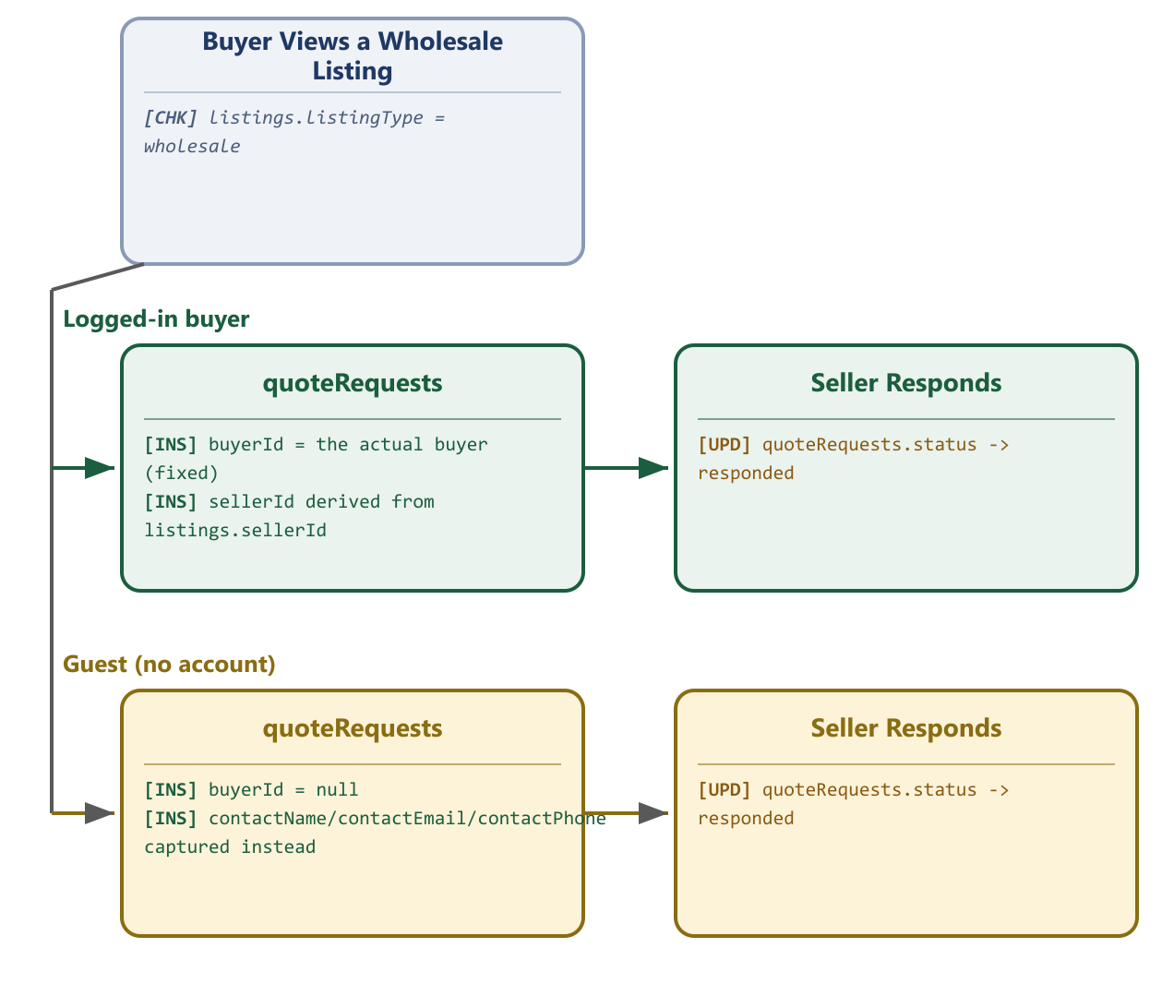
Buyer and seller are both explicit columns — no more overloaded userId; guest inquiries follow the same table.
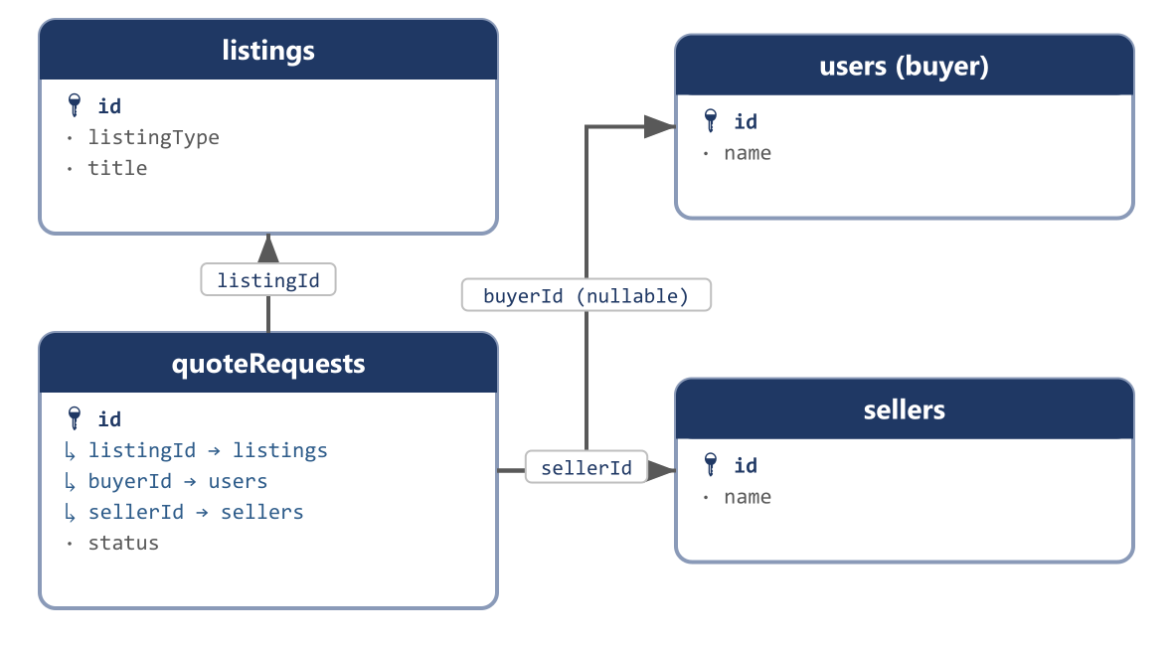
A quote request always resolves to one listing, one seller, and (usually) one buyer.
Replaces: simple_reqs

quoteRequests
How you reach this table: Reached from a wholesale listing's Request a Quote button — a buyer (or a guest without an account) fills in quantity and a message, and this table records the inquiry so the seller can respond with pricing outside the fixed listing price.
A buyer's inquiry against a wholesale (or any) listing, correctly attributing buyerId to the buyer and deriving sellerId from the listing itself.
Field | Type | Description | Example
id | bigint PK | Auto-incrementing primary key. | 1
listingId | bigint FK → listings | The listing this inquiry is about. | 3001
buyerId | bigint FK → users, null | Null only for a guest inquiry; fixed in this redesign to actually mean the buyer. | 501
sellerId | bigint FK → sellers | Derived from listings.sellerId at submission time. | 201
qty | bigint | Quantity the buyer is asking to price. | 100
message | text | The buyer's inquiry message. | Can you do 100 units at a better rate with delivery to Chattogram?
contactName | varchar, null | Kept for guest inquiries without a buyer account. | Mahin Rahman
contactEmail | varchar, null | Kept for guest inquiries. | mahin.rahman@gmail.com
contactPhone | varchar, null | Kept for guest inquiries. | +8801911222333
contactCompany | varchar, null | Kept for guest inquiries. | null
contactCity | varchar, null | Inquiry-time address detail, present on legacy simple_reqs but missed in an earlier pass of this redesign. | Chattogram
contactRoad | varchar, null | Inquiry-time address detail. | Road 4, Agrabad
status | enum(new | responded | closed) | Current state of the inquiry. | responded
createdBy | bigint, null | ID of the actor who created this row — an admin, seller, or user id depending on creatorType; null when the system created it automatically (e.g. a payment gateway webhook). | 14
creatorType | enum(admin | seller | user | system) | Which actor table createdBy points into. A plain numeric id is ambiguous by itself — admins, sellers and users each have their own id sequence, so id 14 could be any of the three without this column. | seller
creatorName | varchar, null | A denormalized snapshot of the creator's display name at the moment this row was written, so an audit screen can show “Created by Rafiq Traders” without joining three different actor tables. | Rafiq Traders
updatedBy | bigint, null | ID of the actor who last modified this row. Same ambiguity as createdBy, resolved the same way. | 14
updaterType | enum(admin | seller | user | system) | Which actor table updatedBy points into. | seller
updaterName | varchar, null | Denormalized snapshot of the last editor's display name at the time of the edit. | Rafiq Traders
createdAt | timestamp | Row-creation timestamp, maintained automatically by the framework. | 2026-03-14 10:22:00
updatedAt | timestamp | Last-modification timestamp, maintained automatically by the framework. | 2026-03-14 10:22:00
Sample data
Field | Sample Record 1
id | 1
listingId | 3001
buyerId | 501
sellerId | 201
qty | 100
message | Can you do 100 units at a better rate with delivery to Chattogram?
contactName | Mahin Rahman
contactEmail | mahin.rahman@gmail.com
contactPhone | +8801911222333
contactCompany | null
contactCity | Chattogram
contactRoad | Road 4, Agrabad
status | responded
createdBy | 501
creatorType | user
creatorName | Mahin Rahman
updatedBy | 501
updaterType | user
updaterName | Mahin Rahman
createdAt | 2026-08-22 09:00:00
updatedAt | 2026-08-22 09:00:00

3.9 Messaging
chats and messages were already reasonably designed; the redesign mainly renames chats to conversations for clarity and confirms the listing-context columns collapse to a single listingId now that the catalog itself is unified. The real-time delivery gap noted in the platform audit (BROADCAST_DRIVER=log, empty Pusher keys) is an infrastructure/config issue, not something the schema can fix.
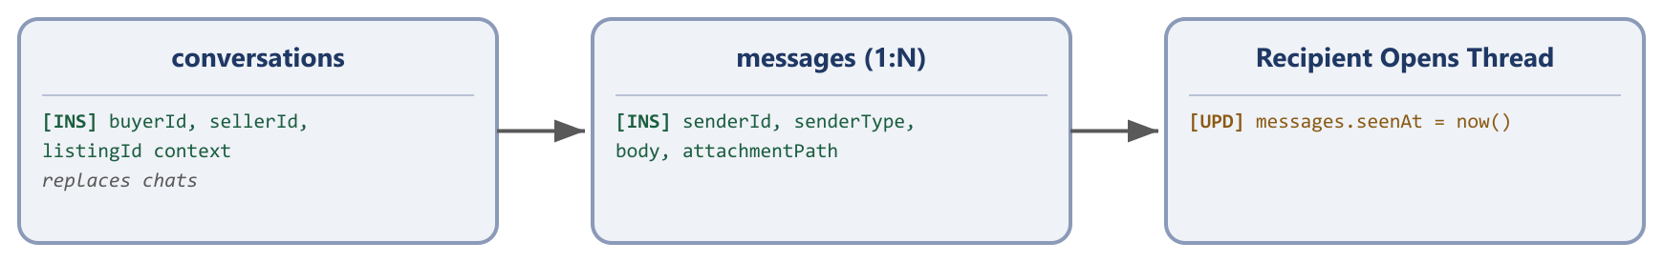
A thread is opened once and reused for every message inside it.
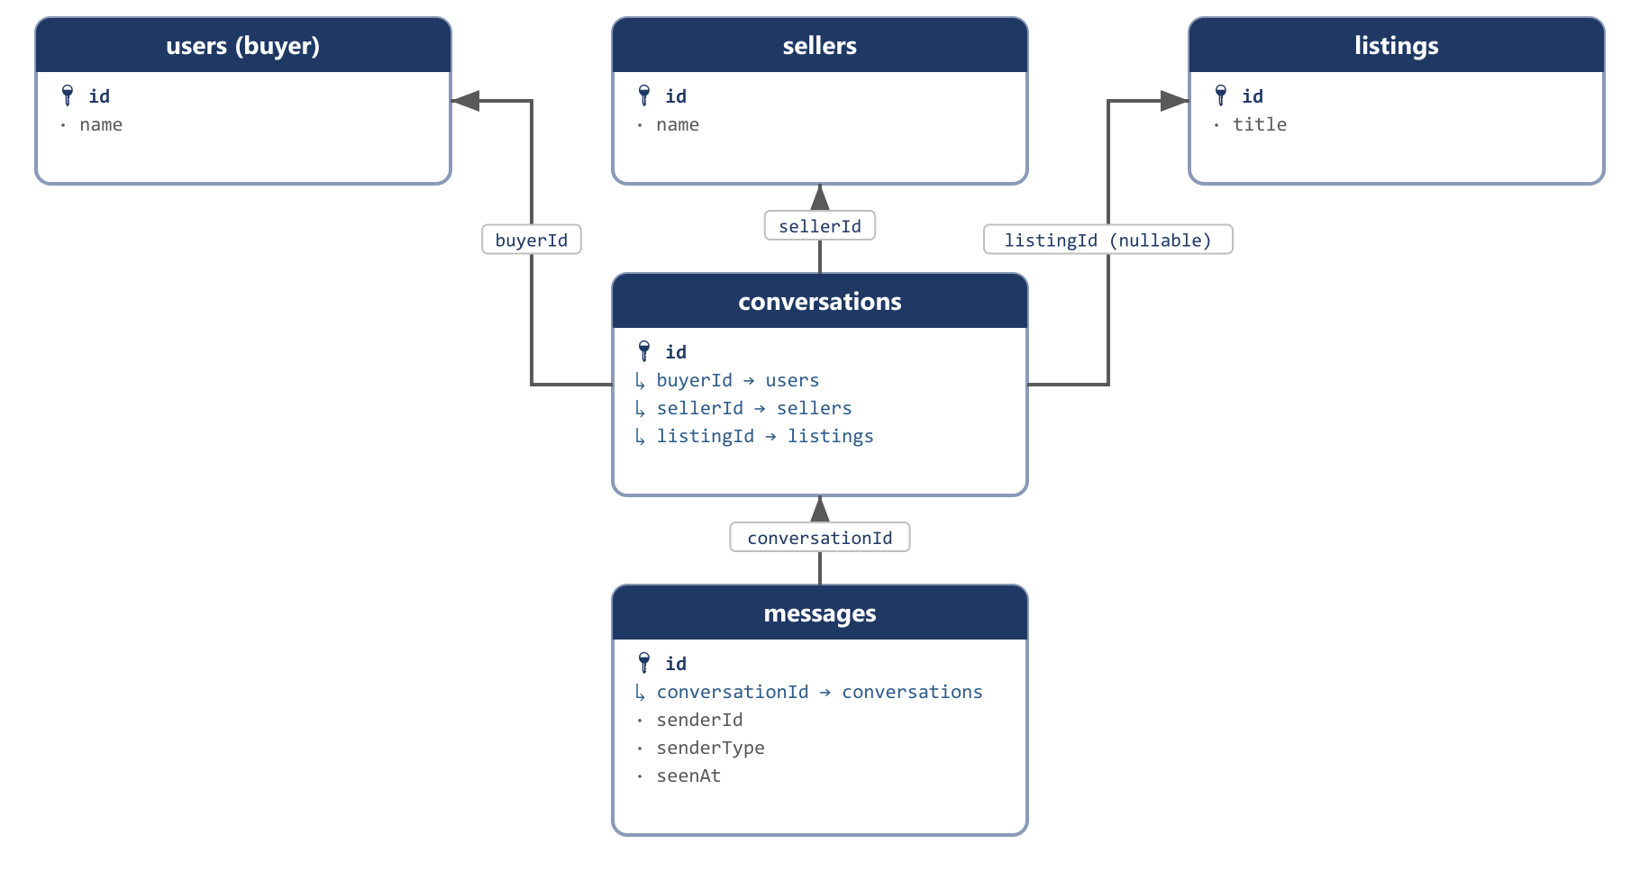
Buyer, seller and an optional listing all anchor one conversation; messages hang off that thread.
Replaces: chats, messages

conversations
How you reach this table: Reached the first time a buyer clicks Message Seller on a listing, or Contact Buyer from a bid/order screen. If a conversation already exists between that exact buyer/seller/listing combination, it is reused rather than duplicated.
One thread between one buyer and one seller, optionally scoped to a specific listing.
Field | Type | Description | Example
id | bigint PK | Auto-incrementing primary key. | 1
buyerId | bigint FK → users | The buyer in this thread. | 501
sellerId | bigint FK → sellers | The seller in this thread. | 201
listingId | bigint FK → listings, null | Conversation context, replacing an untyped plus column. | 3001
createdBy | bigint, null | ID of the actor who created this row — an admin, seller, or user id depending on creatorType; null when the system created it automatically (e.g. a payment gateway webhook). | 14
creatorType | enum(admin | seller | user | system) | Which actor table createdBy points into. A plain numeric id is ambiguous by itself — admins, sellers and users each have their own id sequence, so id 14 could be any of the three without this column. | seller
creatorName | varchar, null | A denormalized snapshot of the creator's display name at the moment this row was written, so an audit screen can show “Created by Rafiq Traders” without joining three different actor tables. | Rafiq Traders
updatedBy | bigint, null | ID of the actor who last modified this row. Same ambiguity as createdBy, resolved the same way. | 14
updaterType | enum(admin | seller | user | system) | Which actor table updatedBy points into. | seller
updaterName | varchar, null | Denormalized snapshot of the last editor's display name at the time of the edit. | Rafiq Traders
createdAt | timestamp | Row-creation timestamp, maintained automatically by the framework. | 2026-03-14 10:22:00
updatedAt | timestamp | Last-modification timestamp, maintained automatically by the framework. | 2026-03-14 10:22:00
Sample data
Field | Sample Record 1
id | 1
buyerId | 501
sellerId | 201
listingId | 3001
createdBy | 501
creatorType | user
creatorName | Mahin Rahman
updatedBy | 501
updaterType | user
updaterName | Mahin Rahman
createdAt | 2026-08-24 11:00:00
updatedAt | 2026-08-24 11:00:00

messages
How you reach this table: Reached only through its parent conversation — every message sent inside a thread, by either party, becomes one row here.
Individual messages within a conversation. seenAt replaces a bare seen tinyint flag with an actual read timestamp.
Granularity intentionally kept at the conversation level — confirm it's acceptable
Legacy messages carried their own listing-context columns (seven mutually-exclusive shop-id fields) on every individual message, so two messages in the same thread could reference two different listings. This redesign keeps listingId only at the conversations level. If buyers and sellers actually do discuss more than one listing inside a single ongoing thread today, add listingId back onto messages directly rather than relying on the parent conversation.
Field | Type | Description | Example
id | bigint PK | Auto-incrementing primary key. | 1
conversationId | bigint FK → conversations | The thread this message belongs to. | 1
senderId | bigint | The buyer or seller id who sent this message. | 501
senderType | enum(buyer | seller) | Which actor table senderId points into. | buyer
body | text, null | Message text. | Hi, is this phone still available?
attachmentPath | varchar, null | Storage path for a single attached file, if any — a message only ever carries one file. | null
attachmentUrl | varchar, null | Public/CDN URL for the same attachment. | null
seenAt | timestamp, null | When the recipient opened this message; null until then. | 2026-08-24 11:05:00
createdBy | bigint, null | ID of the actor who created this row — an admin, seller, or user id depending on creatorType; null when the system created it automatically (e.g. a payment gateway webhook). | 14
creatorType | enum(admin | seller | user | system) | Which actor table createdBy points into. A plain numeric id is ambiguous by itself — admins, sellers and users each have their own id sequence, so id 14 could be any of the three without this column. | seller
creatorName | varchar, null | A denormalized snapshot of the creator's display name at the moment this row was written, so an audit screen can show “Created by Rafiq Traders” without joining three different actor tables. | Rafiq Traders
updatedBy | bigint, null | ID of the actor who last modified this row. Same ambiguity as createdBy, resolved the same way. | 14
updaterType | enum(admin | seller | user | system) | Which actor table updatedBy points into. | seller
updaterName | varchar, null | Denormalized snapshot of the last editor's display name at the time of the edit. | Rafiq Traders
createdAt | timestamp | Row-creation timestamp, maintained automatically by the framework. | 2026-03-14 10:22:00
updatedAt | timestamp | Last-modification timestamp, maintained automatically by the framework. | 2026-03-14 10:22:00
Sample data
Field | Sample Record 1 | Sample Record 2
id | 1 | 2
conversationId | 1 | 1
senderId | 501 | 201
senderType | buyer | seller
body | Hi, is this phone still available? | Yes, still available. Can ship today.
attachmentPath | null | null
attachmentUrl | null | null
seenAt | 2026-08-24 11:05:00 | null
createdBy | 501 | 201
creatorType | user | seller
creatorName | Mahin Rahman | Rafiq Traders
updatedBy | 501 | 201
updaterType | user | seller
updaterName | Mahin Rahman | Rafiq Traders
createdAt | 2026-08-24 11:00:30 | 2026-08-24 11:03:00
updatedAt | 2026-08-24 11:00:30 | 2026-08-24 11:03:00

3.10 Reviews & Favourites
The platform audit found reviews could be submitted with no check that the underlying order was ever completed. Requiring an orderId foreign key (rather than a bare productId/serviceId) makes an uncompleted-order review structurally awkward to create by accident, since the application now has to have a real completed order in hand to attach the review to. favourites drops five mutually-exclusive shop-id columns in favor of one listingId, now that there is one catalog table to point at.
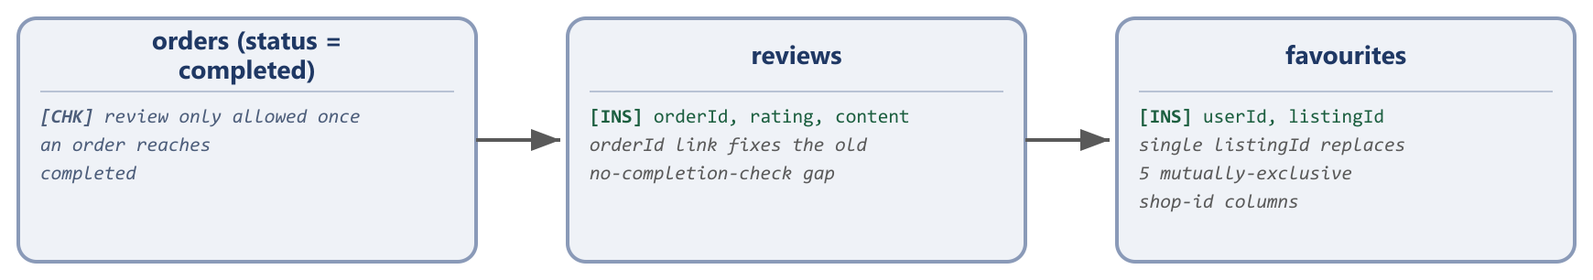
A review always ties back to one specific completed order.
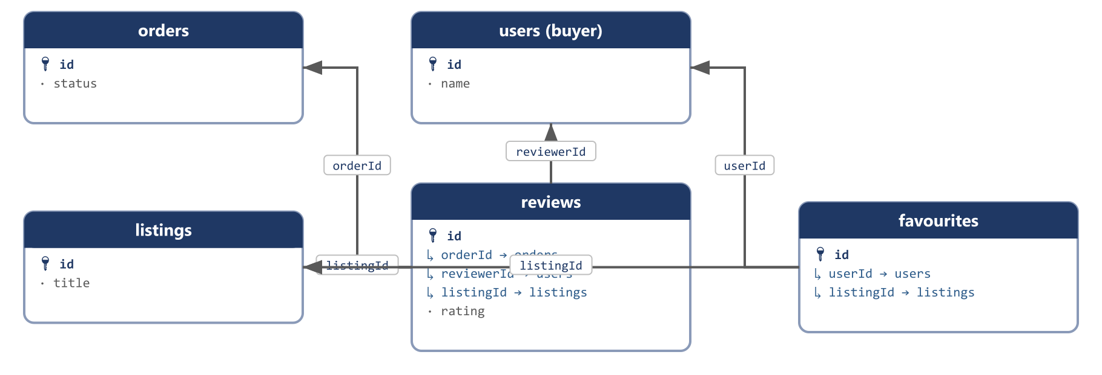
Reviews and favourites both resolve back to a buyer and a listing.
Replaces: reviews, favourits

reviews
How you reach this table: Reached from Order History → Leave a Review, and only shown as an option once orders.status = completed for that order. Submitting the form inserts one row here, tied directly to that specific order.
A buyer's rating and comment on a completed order, denormalizing listingId alongside orderId for fast “all reviews for this listing” queries.
Field | Type | Description | Example
id | bigint PK | Auto-incrementing primary key. | 1
orderId | bigint FK → orders | Ties the review to the specific completed transaction. | 9001
reviewerId | bigint FK → users | The buyer leaving the review. | 501
listingId | bigint FK → listings | Denormalized for fast listing-level review queries. | 3001
rating | tinyint | Star rating, 1–5. | 5
content | text, null | Review text. | Exactly as described, fast delivery.
sellerReply | text, null | The seller's public reply to this review, if any. | Thank you for your order!
createdBy | bigint, null | ID of the actor who created this row — an admin, seller, or user id depending on creatorType; null when the system created it automatically (e.g. a payment gateway webhook). | 14
creatorType | enum(admin | seller | user | system) | Which actor table createdBy points into. A plain numeric id is ambiguous by itself — admins, sellers and users each have their own id sequence, so id 14 could be any of the three without this column. | seller
creatorName | varchar, null | A denormalized snapshot of the creator's display name at the moment this row was written, so an audit screen can show “Created by Rafiq Traders” without joining three different actor tables. | Rafiq Traders
updatedBy | bigint, null | ID of the actor who last modified this row. Same ambiguity as createdBy, resolved the same way. | 14
updaterType | enum(admin | seller | user | system) | Which actor table updatedBy points into. | seller
updaterName | varchar, null | Denormalized snapshot of the last editor's display name at the time of the edit. | Rafiq Traders
createdAt | timestamp | Row-creation timestamp, maintained automatically by the framework. | 2026-03-14 10:22:00
updatedAt | timestamp | Last-modification timestamp, maintained automatically by the framework. | 2026-03-14 10:22:00
Sample data
Field | Sample Record 1
id | 1
orderId | 9001
reviewerId | 501
listingId | 3001
rating | 5
content | Exactly as described, fast delivery.
sellerReply | Thank you for your order!
createdBy | 501
creatorType | user
creatorName | Mahin Rahman
updatedBy | 501
updaterType | user
updaterName | Mahin Rahman
createdAt | 2026-08-28 09:00:00
updatedAt | 2026-08-28 09:00:00

favourites
How you reach this table: Reached from the heart/bookmark icon on any listing card — clicking it while signed in inserts one row here; clicking again removes it.
A buyer's saved/wishlisted listings, one row per listing.
Field | Type | Description | Example
id | bigint PK | Auto-incrementing primary key. | 1
userId | bigint FK → users | The buyer who favourited this listing. | 502
listingId | bigint FK → listings | The listing that was favourited. | 3001
createdBy | bigint, null | ID of the actor who created this row — an admin, seller, or user id depending on creatorType; null when the system created it automatically (e.g. a payment gateway webhook). | 14
creatorType | enum(admin | seller | user | system) | Which actor table createdBy points into. A plain numeric id is ambiguous by itself — admins, sellers and users each have their own id sequence, so id 14 could be any of the three without this column. | seller
creatorName | varchar, null | A denormalized snapshot of the creator's display name at the moment this row was written, so an audit screen can show “Created by Rafiq Traders” without joining three different actor tables. | Rafiq Traders
updatedBy | bigint, null | ID of the actor who last modified this row. Same ambiguity as createdBy, resolved the same way. | 14
updaterType | enum(admin | seller | user | system) | Which actor table updatedBy points into. | seller
updaterName | varchar, null | Denormalized snapshot of the last editor's display name at the time of the edit. | Rafiq Traders
createdAt | timestamp | Row-creation timestamp, maintained automatically by the framework. | 2026-03-14 10:22:00
updatedAt | timestamp | Last-modification timestamp, maintained automatically by the framework. | 2026-03-14 10:22:00
Sample data
Field | Sample Record 1
id | 1
userId | 502
listingId | 3001
createdBy | 502
creatorType | user
creatorName | Sumaiya Akter
updatedBy | 502
updaterType | user
updaterName | Sumaiya Akter
createdAt | 2026-08-26 20:00:00
updatedAt | 2026-08-26 20:00:00

3.11 Notifications
Laravel's standard polymorphic notifications table is already well-designed and needs no schema change — it stays exactly as-is, including its snake_case column names, since changing a framework-owned table's shape would fight the framework rather than the application. The audit's ownership-check gap (marking a notification read by id alone, without checking it belongs to the current user) is an application-code fix, not a schema one. Because this table is written exclusively by the framework itself, it does not carry the createdBy/creatorType audit block used everywhere else — there is no ambiguity to resolve; the actor is always “system.”
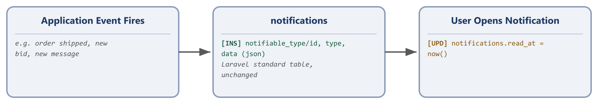
System-driven — nobody fills in a form to create a notification.
Unchanged from the legacy schema.

notifications
How you reach this table: Reached indirectly: any event the application fires a Laravel notification for (an order status change, a new bid, a new message) writes one row here automatically. Nobody creates a notification by filling in a form.
Laravel's standard notifications table, unchanged.
Field | Type | Description | Example
id | char(36) PK | UUID, unchanged. | 3fa85f64-5717-4562-b3fc-2c963f66afa6
notifiable_type | varchar | The class name of the notified model, e.g. App\Models\User. | App\Models\User
notifiable_id | bigint | The id of the notified model. | 501
type | varchar | The notification class name. | App\Notifications\OrderShipped
data | text | JSON payload of the notification content. | {"orderId":9001,"message":"Your order has shipped"}
read_at | timestamp, null | When the notification was read; null until then. | null
created_at | timestamp | Row-creation timestamp. | 2026-08-27 10:00:00
updated_at | timestamp | Last-modification timestamp. | 2026-08-27 10:00:00

3.12 CMS & Site Settings
banners and sidebar_banners were the same concept (a promotional image with a link) at two different placements, so they merge into one banners table with a placement column. email_contents becomes emailTemplates with an explicit isActive flag — making the audit's finding (most Mail::send() dispatch calls are commented out) visible directly in the data model, so a template that exists but is never sent is now a distinct, queryable state rather than a silent code-level omission. The others key/value settings table becomes a proper key → JSON value store instead of three fixed value1/value2/value3 columns.
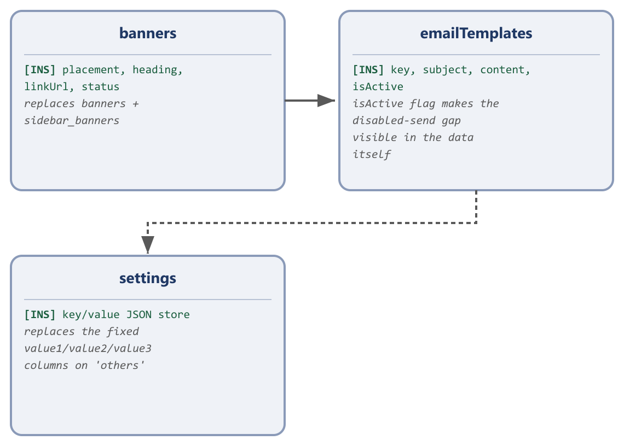
Three focused content tables replace four, each with a clear single purpose.
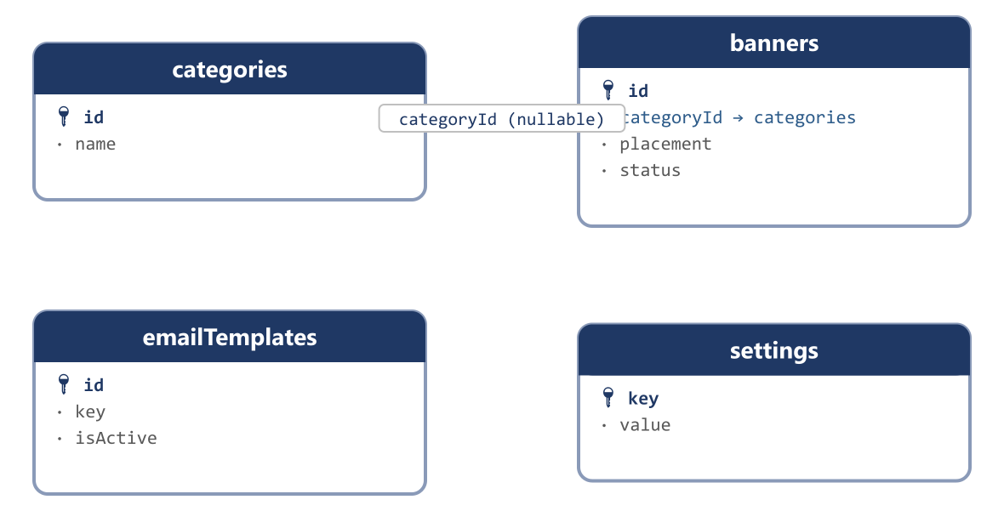
A banner may optionally target one category; templates and settings stand alone.
Replaces: banners, sidebar_banners, email_contents, others

banners
How you reach this table: Reached only from the admin panel's Banner Management screen — an admin uploads an image, picks a placement, and optionally schedules it with startsAt/endsAt.
One promotional-banner table for every placement, replacing two nearly-identical legacy tables and their duplicate status columns.
Ambiguous legacy columns — confirm before dropping
Legacy banners actually carries two independent status columns (status default 2, statusS default 4) and sidebar_banners carries two separate int discriminators (type, what) beyond categoryId. Their exact intended meaning isn't recoverable from the schema alone — this redesign collapses each pair down to the single status/placement columns below. Check the admin panel's banner-management screens for a second toggle or filter before finalizing.
Field | Type | Description | Example
id | bigint PK | Auto-incrementing primary key. | 1
placement | enum(hero | sidebar | category) | Where this banner is displayed. | hero
heading | varchar, null | Main banner heading text. | Eid Collection is Here
smallHeading | varchar, null | Secondary/smaller heading text. | Up to 40% off
linkUrl | varchar, null | Where the banner links to when clicked. | /categories/electronics
imagePath | varchar, null | Storage path — a banner has exactly one image, no dedicated gallery table needed. | banners/eid-hero.jpg
imageUrl | varchar, null | Public CDN URL for the same image. | https://cdn.egoola.com/banners/eid-hero.jpg
categoryId | bigint FK → categories, null | Sidebar placement only. | null
status | enum(active | inactive) | Whether this banner is currently shown. | active
sortOrder | int | Display order among banners in the same placement. | 1
startsAt | timestamp, null | Scheduling — a new capability the legacy schema didn't have. | 2026-08-01 00:00:00
endsAt | timestamp, null | Scheduling end date. | 2026-08-31 23:59:59
createdBy | bigint, null | ID of the actor who created this row — an admin, seller, or user id depending on creatorType; null when the system created it automatically (e.g. a payment gateway webhook). | 14
creatorType | enum(admin | seller | user | system) | Which actor table createdBy points into. A plain numeric id is ambiguous by itself — admins, sellers and users each have their own id sequence, so id 14 could be any of the three without this column. | seller
creatorName | varchar, null | A denormalized snapshot of the creator's display name at the moment this row was written, so an audit screen can show “Created by Rafiq Traders” without joining three different actor tables. | Rafiq Traders
updatedBy | bigint, null | ID of the actor who last modified this row. Same ambiguity as createdBy, resolved the same way. | 14
updaterType | enum(admin | seller | user | system) | Which actor table updatedBy points into. | seller
updaterName | varchar, null | Denormalized snapshot of the last editor's display name at the time of the edit. | Rafiq Traders
createdAt | timestamp | Row-creation timestamp, maintained automatically by the framework. | 2026-03-14 10:22:00
updatedAt | timestamp | Last-modification timestamp, maintained automatically by the framework. | 2026-03-14 10:22:00
Sample data
Field | Sample Record 1
id | 1
placement | hero
heading | Eid Collection is Here
smallHeading | Up to 40% off
linkUrl | /categories/electronics
imagePath | banners/eid-hero.jpg
imageUrl | https://cdn.egoola.com/banners/eid-hero.jpg
categoryId | null
status | active
sortOrder | 1
startsAt | 2026-08-01 00:00:00
endsAt | 2026-08-31 23:59:59
createdBy | 1
creatorType | admin
creatorName | Super Admin
updatedBy | 1
updaterType | admin
updaterName | Super Admin
createdAt | 2026-07-28 10:00:00
updatedAt | 2026-07-28 10:00:00

emailTemplates
How you reach this table: Reached only from the admin panel's Email Templates screen — an admin edits the subject/content for a given key, and toggles isActive to control whether the application actually sends it.
Transactional email content, keyed by a stable identifier the application code references directly.
Field | Type | Description | Example
id | bigint PK | Auto-incrementing primary key. | 1
key | varchar, unique | Stable identifier the application code looks up. | order_approved
subject | varchar | Email subject line. | Your Egoola order has been approved
content | text | Email body, supports template variables. | Hi {{buyerName}}, your order #{{orderId}} has been approved.
isActive | boolean | Makes a template that is never actually dispatched a visible, queryable fact. | true
createdBy | bigint, null | ID of the actor who created this row — an admin, seller, or user id depending on creatorType; null when the system created it automatically (e.g. a payment gateway webhook). | 14
creatorType | enum(admin | seller | user | system) | Which actor table createdBy points into. A plain numeric id is ambiguous by itself — admins, sellers and users each have their own id sequence, so id 14 could be any of the three without this column. | seller
creatorName | varchar, null | A denormalized snapshot of the creator's display name at the moment this row was written, so an audit screen can show “Created by Rafiq Traders” without joining three different actor tables. | Rafiq Traders
updatedBy | bigint, null | ID of the actor who last modified this row. Same ambiguity as createdBy, resolved the same way. | 14
updaterType | enum(admin | seller | user | system) | Which actor table updatedBy points into. | seller
updaterName | varchar, null | Denormalized snapshot of the last editor's display name at the time of the edit. | Rafiq Traders
createdAt | timestamp | Row-creation timestamp, maintained automatically by the framework. | 2026-03-14 10:22:00
updatedAt | timestamp | Last-modification timestamp, maintained automatically by the framework. | 2026-03-14 10:22:00
Sample data
Field | Sample Record 1
id | 1
key | order_approved
subject | Your Egoola order has been approved
content | Hi {{buyerName}}, your order #{{orderId}} has been approved.
isActive | true
createdBy | 1
creatorType | admin
creatorName | Super Admin
updatedBy | 1
updaterType | admin
updaterName | Super Admin
createdAt | 2024-01-02 00:00:00
updatedAt | 2024-01-02 00:00:00

settings
How you reach this table: Reached only from the admin panel's General Settings screen — each named setting is edited independently, and application code reads it by key at request time.
A generic key → JSON value store for site-wide configuration, replacing three fixed value1/value2/value3 columns that forced every setting into the same rigid shape.
Field | Type | Description | Example
key | varchar PK | The setting's unique name. | commission_rate_default
value | json | The setting's value, any JSON shape. | 10
createdBy | bigint, null | ID of the actor who created this row — an admin, seller, or user id depending on creatorType; null when the system created it automatically (e.g. a payment gateway webhook). | 14
creatorType | enum(admin | seller | user | system) | Which actor table createdBy points into. A plain numeric id is ambiguous by itself — admins, sellers and users each have their own id sequence, so id 14 could be any of the three without this column. | seller
creatorName | varchar, null | A denormalized snapshot of the creator's display name at the moment this row was written, so an audit screen can show “Created by Rafiq Traders” without joining three different actor tables. | Rafiq Traders
updatedBy | bigint, null | ID of the actor who last modified this row. Same ambiguity as createdBy, resolved the same way. | 14
updaterType | enum(admin | seller | user | system) | Which actor table updatedBy points into. | seller
updaterName | varchar, null | Denormalized snapshot of the last editor's display name at the time of the edit. | Rafiq Traders
createdAt | timestamp | Row-creation timestamp, maintained automatically by the framework. | 2026-03-14 10:22:00
updatedAt | timestamp | Last-modification timestamp, maintained automatically by the framework. | 2026-03-14 10:22:00
Sample data
Field | Sample Record 1
key | commission_rate_default
value | 10
createdBy | 1
creatorType | admin
creatorName | Super Admin
updatedBy | 1
updaterType | admin
updaterName | Super Admin
createdAt | 2024-01-01 00:00:00
updatedAt | 2024-01-01 00:00:00

4. Appendix: Full Old → New Table Mapping
Every one of the 71 legacy tables, and where its data lands in the new schema. Use this as the source list when writing the actual migration/backfill scripts. New-schema table and field names are given in camelCase throughout, matching Section 3; legacy table names are left exactly as they appear in the live database, since those are the literal source tables a migration script will SELECT from.
Legacy table | New table(s) / disposition
users | sellers / users (split by role)
user_infos | sellers / users (columns folded onto the row)
verifies | sellers.emailOtp* / users.emailOtp*
verify_phone | sellers.phoneOtp* / users.phoneOtp*
otps | sellers.phoneOtp* / users.phoneOtp*
otp_logs | sellers.phoneOtpAttempts / users.phoneOtpAttempts
forget_otps | sellers.passwordResetToken / users.passwordResetToken
password_resets | sellers.passwordResetToken / users.passwordResetToken (dropped as a table)
contacts | sellerInfos (folded — publicEmail/whatsapp/facebook/wechat/skype)
skills | sellers.skills (json)
interests | dropped — confirm still in use before migrating; not referenced in the reviewed audit
edcations | sellers.education (json)
experiences | sellers.experience (json)
companies | sellerInfos
company_files | sellerMedia (mediaFor = gallery_image | gallery_video)
certificats | sellerMedia (mediaFor = certificate)
documents | listingMedia (mediaType = document) — corrected in an earlier revision; brand_wall_id shows this is listing-owned, not seller-owned
countries | countries (unchanged)
states | states (unchanged)
cities | cities (unchanged)
unions | thanas (renamed for clarity; now the enforced FK target for every thanaId column)
upazilas | dropped — confirmed dormant duplicate
grand_categories | categories (parentId = null, type = product)
parent_categories | categories (type = product)
child_categories | categories (type = product)
service_grands | categories (parentId = null, type = service)
service_parents | categories (type = service)
service_children | categories (type = service)
products | listings (catalogType = product, listingType = general)
product_images | listingMedia
used_malls | listings (listingType = used)
village_products | listings (listingType = village)
retail_shops | listings (listingType = retail)
wholesales | listings (listingType = wholesale) + listingPriceTiers
brand_walls | listings (listingType = brand)
measurements | measurements (unchanged, FK from listings.measurementId)
services | listings (catalogType = service)
service_images | listingMedia
service_orders | orders (orderType = service)
bid_for_services | bids
hireds | orders (orderType = job)
hire_pays | payments (orderId set, purpose = checkout_payment)
carts | carts (header) + cartItems (kept, split into pre-checkout staging pair)
sales | orders
orders | orders (merged in)
order_pays | payments
billings | orderItems
shippings | addresses
delivery_costs | listings-level or seller-level setting — fold into sellerInfos as a shipping-cost field, or keep as a small deliveryRates table if tiered by weight/region
simple_reqs | quoteRequests
payments | payments (merged in)
payment_requests | payments (purpose = seller_payout, status = pending)
balances | payments (direction = credit, purpose = refund) or users.walletBalance
refund_histories | payments (purpose = refund)
transactions | payments (unified ledger)
commissions | orders.commissionAmount (snapshot) + payments (purpose = commission_payment)
commission_payments | payments (purpose = commission_payment)
seller_payments | payments (purpose = seller_payout)
reviews | reviews
favourits | favourites
chats | conversations
messages | messages
notifications | notifications (unchanged)
banners | banners (placement = hero)
sidebar_banners | banners (placement = sidebar)
email_contents | emailTemplates
others | settings
visitors | dropped, or replaced with a real page_views table — confirmed dormant, zero writes anywhere in the app today; see Section 5
jobs | jobs (unchanged — Laravel queue)
failed_jobs | failed_jobs (unchanged)
migrations | migrations (unchanged)

5. Coverage Verification Against the Legacy Schema
Table-level, this redesign accounts for all 71 legacy tables (Section 4). Table-level coverage isn't the same as column-level coverage, though, so this section documents a second, stricter pass: every column of every legacy table was checked against the new schema directly. That pass found several categories of issue, corrected in this revision except where explicitly flagged as an open question.

Fixed in this revision
Legacy / prior-revision item | Issue found | Fix
users.remember_token | Dropped entirely — no column carried it forward | Added rememberToken to sellers and users
contacts (whatsapp/facebook/wechat/skype/email) | An earlier revision said “folded into sellerInfos” but no columns were ever added | Added publicEmail/whatsapp/facebook/wechat/skype to sellerInfos
documents.brand_wall_id | Mapped to sellerMedia in an earlier draft, but the column is owned by a listing, not a seller | Re-mapped to listingMedia
products.import / type / capacity / "other" (all 6 shop tables) | No column anywhere for these format-specific extras | Added listings.attributes (json)
products.alrqty | Allocated/sold-so-far quantity had no home | Added listings.reservedQty
used_malls.purchase_date/use_day/use_month/use_year, products.use | Item-age/condition fields had no home | Added listings.conditionNote
wholesales.colors/sizes, brand_walls.colors/sizes | Multi-option variant lists had no home | Added listings.colors/sizes (json)
services.include, bid_for_services/services.start_time/end_time | Package details and project deadline window had no home | Added listings.packageIncludes/availableFrom/availableTo, bids.proposedStart/proposedEnd
service_orders.file | Delivered-work attachment had no home | Added orderItems.deliverablePath
orders.secret | The delivery-confirmation token behind the audit's "mail never sent" finding had no home | Added orders.confirmationSecret
payment_requests.account_number | Payout destination account had no home | Added payments.payoutAccountNumber
simple_reqs.state/city/road | Inquiry-time address detail had no home | Added quoteRequests.contactCity/contactRoad
payments.userId | Documented as a "polymorphic reference" with no column actually saying which table it points into — the same ambiguity this revision's audit-trail fields exist to prevent, present here even before the audit trail was added | Added payments.userType (enum: seller | user)
measurements, visitors | Both were referenced in the old Section 4 mapping appendix but neither was ever counted in the Section 2 before/after summary table, so its legacy-table total silently undercounted by two | measurements now has a full table definition in Section 3.5 and is counted in Section 2; visitors is now explicitly counted (and dropped) in Section 2's Notifications & system row

Also fixed in this revision: naming and structure
- Every field name across every table converted from snake_case to camelCase, including inside enum value examples and the Section 4 mapping appendix.
- Every table gained the same six-field audit trail (createdBy/creatorType/creatorName, updatedBy/updaterType/updaterName) — see the philosophy bullet in Section 1 for why this is necessary once identity is split three ways, not optional polish.
- adminMedia and buyerMedia are new tables in this revision, giving admin and buyer accounts the same dedicated-gallery treatment sellers and listings already had; previously only sellers and listings owned their own media table, and an admin or buyer's profile photo lived as a bare path column with no room to grow into a document gallery later.
- Every multi-field table cell from earlier drafts (e.g. a single row reading “name, email (unique), mobile”) is split into one row per field throughout Section 3, so the field table is a literal column list, not a paraphrase of one.

Flagged, not guessed at
A handful of legacy columns have ambiguous or undocumented intent that isn't recoverable from the schema dump alone — guessing at these in a redesign would risk quietly encoding a wrong assumption. Each is called out where it appears (Sections 3.4, 3.9, 3.12) rather than resolved here:
- grand_categories.section / service_grands.section — featured flag, or a scope tying a category branch to one specific listing format?
- banners.statusS, sidebar_banners.type/what — a second status/discriminator beyond the ones this redesign kept.
- billings.delivary (per-line-item delivery status) — only relevant if a single order's items can ship separately; the new schema tracks status at the order level only.
- messages' seven per-message listing-context columns — only relevant if one chat thread ever discusses more than one listing; the new schema tracks listing context at the conversation level only.
Storage engine and charset
About a dozen legacy tables run on MyISAM (which cannot enforce foreign keys at all) and a few still use latin1_swedish_ci. That is the direct reason so many of today's relationships are “implicit” rather than constrained — Section 4 of the source database document lists them. Every new table in this proposal assumes InnoDB and utf8mb4_unicode_ci uniformly; standardizing storage engine and charset is a prerequisite step in the actual migration, not just a schema-shape change.

6. Migration Considerations & Open Decisions
The items below are the open questions and practical sequencing notes that a redesign like this one always surfaces. None of them block reviewing the schema itself — they matter once someone actually sits down to write migration scripts.
- Buyer/Seller dual accounts. Confirm whether a single person should ever hold both a users and a sellers row under one login (see the callout in Section 3.2). This decision changes the shape of the identity tables, so it should be settled before any migration script is written.
- Backfilling the audit trail on historical rows. createdBy/creatorType/creatorName have no equivalent in the legacy schema at all, so every row migrated from the old database will need these columns backfilled with a best-effort guess (typically creatorType = system, creatorName = "Migrated from legacy system") rather than a real historical actor, since the legacy schema simply never recorded who created most of these rows.
- delivery_costs has no obvious 1:1 new home. It is currently a flat per-seller shipping fee/threshold. Recommend folding it into sellerInfos as a couple of scalar columns unless shipping cost actually varies by listing or region, in which case a small deliveryRates table (sellerId, region, cost, freeThreshold) is cleaner than reintroducing a dedicated table for a single fact.
- interests table. Not referenced anywhere in the audit or in the diagrams reviewed; confirm it is still live in the product before deciding whether it needs a new home at all.
- visitors / analytics. The audit confirmed this table is entirely dormant — zero code paths write to it despite the migration, model relation, and a dashboard widget all existing. Decide whether to drop it outright or take this migration as the opportunity to wire up a real page_views table if visitor analytics is actually wanted going forward.
- Recursive category queries. The categories self-join tree needs either application-level recursive fetching (cache the full tree, it rarely changes) or a WITH RECURSIVE query — supported by the live MariaDB 11.4 server, so no database upgrade is required.
- Data migration order. Geography (countries/states/cities/thanas) and categories have no dependencies and can migrate first. Identity tables (admins/sellers/users) depend only on geography. Listings depends on sellers, users and categories. Orders/orderItems/payments depend on listings, users and sellers, and should migrate last given how many legacy tables feed into them.
- This is a schema proposal, not a running migration. Nothing here has been applied to the live database. The next step, once the open decisions above are settled, is to write the actual Laravel migration files and a one-time backfill script per the mapping table in Section 4.

7. Summary
This proposal takes the 71-table legacy schema down to 35 tables by applying one consistent idea repeatedly: wherever several tables share the same shape and differ only in a type or a format tag, they become one table with that tag as a column. Categories gain unlimited depth for the cost of one self-referencing column. The five/seven-way listing duplication becomes one catalog with per-format flags. The order/payment sprawl — fourteen tables split across a product path and a service path that had drifted apart and picked up different bugs — becomes one order pipeline and one payment ledger. Several of the bugs documented in the companion Platform Overview audit (the withdrawal-sums-everyone bug, the wrong-owner bug on buyer inquiries, the earnings-ledger asymmetry between the two hire paths, the operator-precedence cancel-guard bug) are closed by this structure directly, not just patched in application code.
This revision is a presentation-and-completeness pass on top of that same structural design, not a re-architecture: every field across every one of the 35 tables is now named in camelCase, documented one field per row with its own description and a realistic example value, and demonstrated with two fully worked sample records per table drawn from one consistent, recurring cast of example accounts and listings. Every table opens with a plain-language account of the real user action that produces a row in it. Every business table carries the same six-field audit trail, closing an ambiguity (a bare numeric "who did this" id) that would otherwise have quietly reappeared the moment identity was split into three separate tables. The diagram set more than doubles, from 11 diagrams to 25 — an updated flow diagram for every journey, several new flow diagrams for sub-journeys that previously had none, and a new relationship diagram for every module showing exactly how its tables connect through foreign keys. A full column-by-column re-check (Section 5) closed a further fourteen gaps, including one — payments.userId — that had been sitting in the schema as an undocumented, untyped "polymorphic reference" since the very first revision. The open decisions in Section 6 — principally, whether buyer and seller should ever share one login, and how to backfill an audit trail the legacy database never recorded — are the right next conversation before any migration script gets written.

